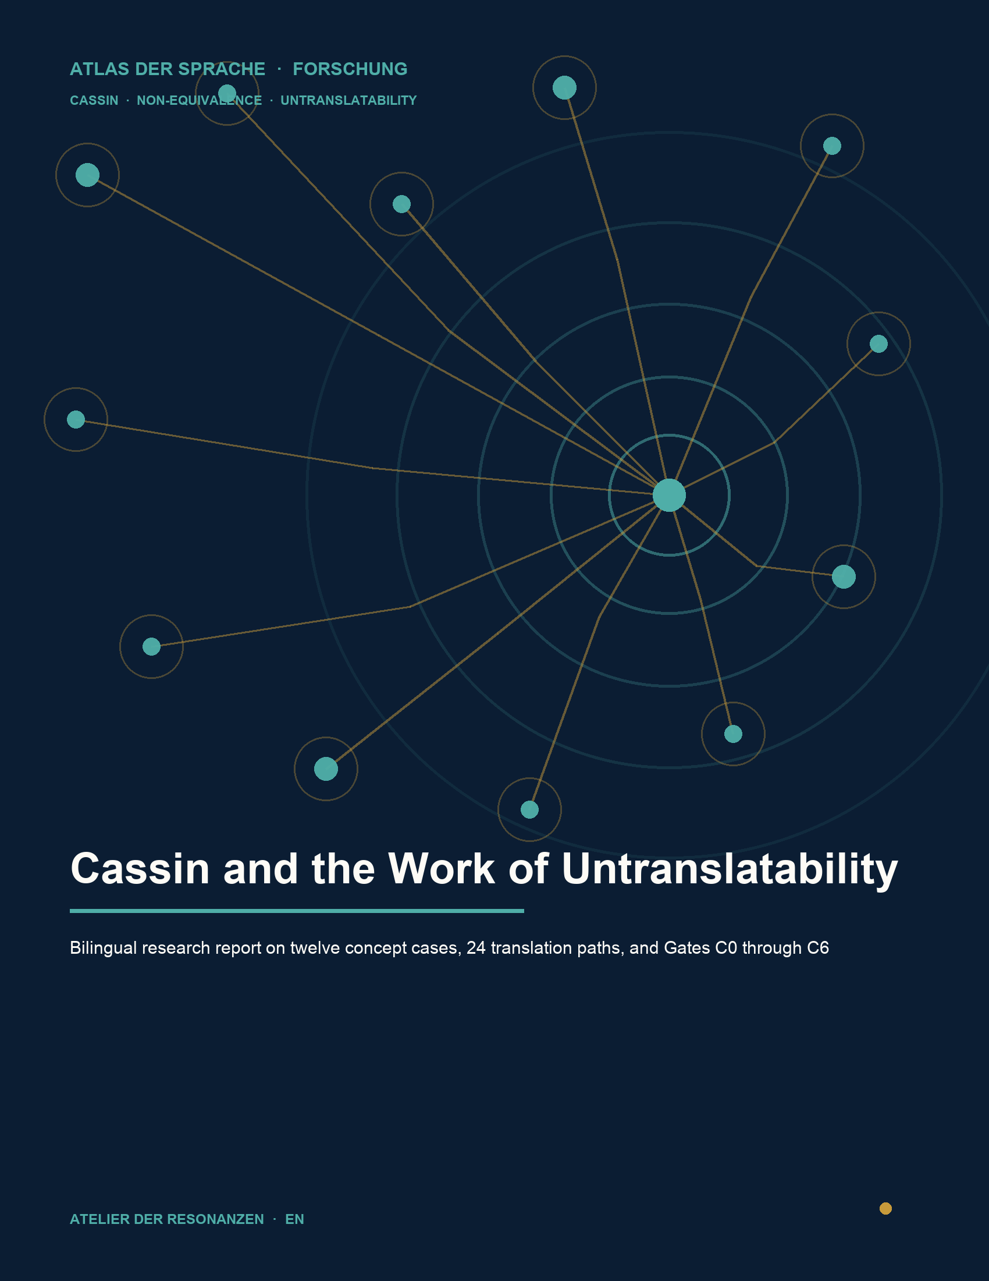

RESEARCH REPORT 03 · ENGLISH EDITION

Cassin and the Work of Untranslatability
Research report on twelve concept cases, 24 translation paths, and Gates C0 through C6
Michael Reich · Version 1.1 · 13 September 2026

Abstract
The Cassin pilot examines non-equivalence and untranslatability across twelve selected concepts in the Atlas of Language. Its comparison corpus comprises the 2004 French edition and the 2014 English edition of the philosophical lexicon, together with independent primary texts, historical and specialist dictionaries, published translations of identical passages, and explicit countermodels. Twelve same-passage groups containing 24 directly verified published translation paths were coded in two separate model runs, adjudicated, and subjected to adversarial review. Four paths received A, thirteen B, five C, and two X. Nine of the twelve groups differ in grade or mechanism. The result is not a list of absolutely untranslatable words. It is a graded model of context-dependent correspondence in which polysemy distribution, word formation, historical sedimentation, institutional pragmatics, disciplinary shift, and translation chains interact. Five Atlas anchors require no special change within the pilot's scope, four require contextual qualification, and three are later revision candidates. This classification is a research finding, not an integration selection. Human, native-speaker, and personally independent review is unavailable; CP-011 therefore remains open with two X paths. Gate C6 is complete with mandatory reservations. This report documents Gate C7 but changes no Atlas data and grants no publication approval.
Metric | Result
Cases | 12
Same-passage groups | 12
Published translation paths | 24
C4 | A 4 · B 13 · C 5 · X 2
Gate state | C6 complete · C7 report package

Contents and reading path
Part | Section
I | cover, abstract, reading path, and status
II | research question, concepts, corpus, and gates
III | twelve continuous case dossiers
IV | comparative results and Atlas consequences
V | methods appendix
VI | case, path, and source registers
VII | reproduction, citation, and transparency

Reading principle
Source finding, Cassin structure, countermodel, and Atlas consequence have separate validity. Every case analysis keeps these layers visibly distinct. The machine-readable registers remain authoritative for individual decisions.

Status and decision boundary
Gate | State | Meaning
C0 | editions fixed | with rights and page reservations
C1 | 12/12 | Atlas anchors read back
C2 | 12/12 | structural decisions
C3 | 12 · 24 · 24 | groups · pairs · paths
C4 | 24/24 | finally adjudicated
C5 | bounded pass | nonhuman adversarial review
C6 | complete | with mandatory reservations
C7 | report package | no Atlas integration

C7 produces a verified report package. It opens neither canonical Atlas integration nor public publication. Research completion, editorial selection, data mutation, and deployment remain different states.
FINAL STATE C7_REPORT_PACKAGE_COMPLETE_WITH_MANDATORY_RESERVATIONS

1 Research object and guiding questions
The project asks how philosophically and culturally layered concepts can be compared across languages without presupposing word identity, conceptual identity, or absolute untranslatability. The twelve cases combine translation metaconcepts, boundary concepts, and culturally bounded scope controls.
1. What structure does each case have in FR2004 and EN2014?
2. Which historical and specialist evidence supports or limits the concept?
3. What do two published translations of the same passage show under one predeclared criterion?
4. Which countermodel prevents a self-confirming interpretation?
5. What research consequence follows for the Atlas anchor without changing it?

2 Central result
In the pilot, non-equivalence appears as a combination of mechanisms rather than a property of isolated words. Even the four A paths apply only in tightly bounded specialist contexts. B and C dominate because published translations preserve relations while shifting semantic margins, grammatical packaging, or institutional function.
Observation | Meaning
4/24 A | broad interchangeability remains rare and microtext-bound
13/24 B | conventional contextual equivalence is the modal result
5/24 C | relevant overlap with different boundaries
2/24 X | evidence and review are insufficient for CP-011
9/12 | paired groups differ in grade or mechanism

3 Conceptual working vocabulary
Term | Working definition
Correspondence | observed relation in a named context
Equivalence | justified interchangeability or commensurability under one criterion
Non-equivalence | relevant difference despite possible translatability
Untranslatability | parameterised limit of lossless formal and functional identity
Absence | documented non-finding in the checked edition corpus
Countermodel | explicit theory that limits or re-parameterises the guiding claim

BOUNDARY Non-equivalence is not automatically untranslatability; corpus absence is not a semantic negative finding.

4 Corpus and editions
Corpus | Function | Status
FR2004 | French base edition | complete structural review
EN2014 | English comparison and transformation edition | complete structural review through licensed online access
Primary texts | historical concept and use layers | S2
Lexicography | forms, dating, and semantic fields | S3
Same passage | two published targets per source passage | S4
Countermodels | adversarial theory test | S5

The non-digital French new edition of 2019 was not retained as a completion condition after the project decision. The English comparison promised greater value for the English Atlas edition. Absence claims therefore remain strictly bounded to FR2004 and EN2014.

5 Gate sequence C0 through C7
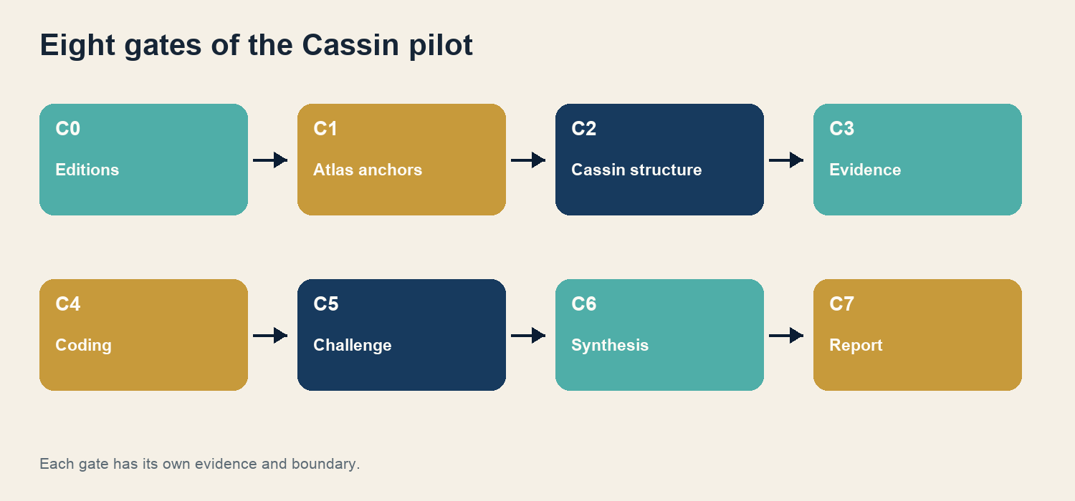
Fig. 1 · The gate sequence separates acquisition, structural review, evidence, coding, synthesis, and reporting.
A later gate does not replace an earlier one. C4 codes do not remove rights reservations; C5 simulations do not replace human review; C7 does not make research findings ready for integration.

6 Gate C0 editions and rights
C0 fixed work identity, edition, access, pagination, and quotation boundary before the twelve concepts were classified. FR2004 was treated as the French reference and EN2014 as an independent comparison edition. Access to a file or platform was never interpreted as an open reuse licence.
1. bibliographic identity before page citation
2. page stability separate from work identity
3. text rights separate from scan and platform rights
4. short quotation instead of full-text copying for protected translations

7 Gate C1 Atlas readback
For every case, the current canonical Atlas short definition was read back with its Atlas ID. This readback is a controlled starting description, not a target that the research must confirm. The case registers therefore keep the Atlas anchor separate from the research consequence.
Case group | Cases | Test function
A | CP-001–003 | translation metaconcepts
B | CP-004–006 | boundaries among word, discipline, and history
C | CP-007–009 | philosophical concepts
D | CP-010–012 | scope and cultural controls

8 Gate C2 Cassin structure
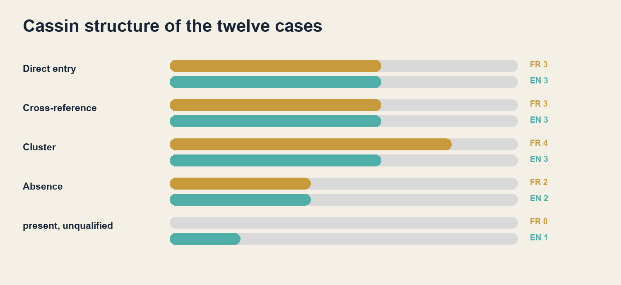
Fig. 2 · FR2004 and EN2014 have similar aggregate distributions but not identical case structures.
C2 assigned one edition-bound structural class per case: direct entry, cross-reference, translation cluster, or documented absence. For Aporia, EN2014 remained present but not cluster-qualified. The classification describes editorial visibility, not philosophical meaning.

9 Gate C3 evidence architecture
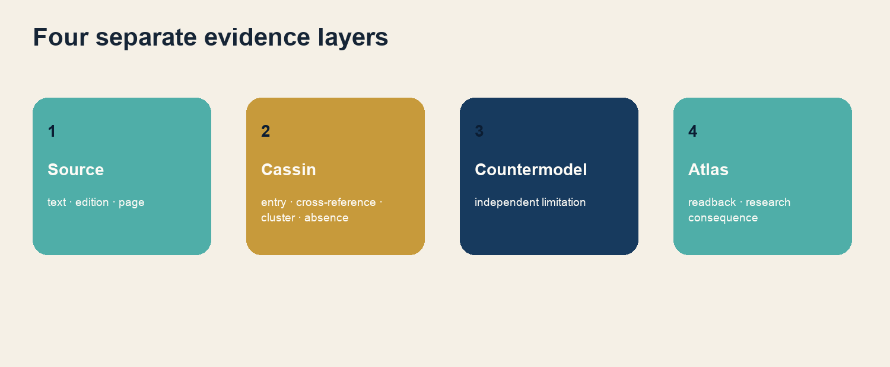
Fig. 3 · Four evidence layers prevent backward inference from the Atlas target to the source.
Each dossier combines primary text, lexicography, a same-passage comparison, a countermodel, negative findings, and a review packet. C3 closed with 164 sources, 164 rights records, 173 passages, 205 negative findings, and 67 simulation records.

10 Sources and rights
Unit | Count | Control rule
Sources | 164 | citation, language, edition, locator
Rights | 164 | internal research and public reuse separated
Passages | 173 | word count, rights ID, same-passage group
protected passages over 25 words | 0 | short-quotation limit observed

The rights finding is conservative and is not legal advice. Public-domain historical texts, modern translations, platform transcriptions, and scan images are treated separately. Public readability is not treated as permission to republish.

11 Same-passage design
Each group links one identical source passage to two published translations. Exactly one criterion was fixed before evaluation. A difference therefore cannot be manufactured afterwards by switching among form, meaning, style, or effect.
1. fix the source passage bibliographically and by page
2. check rights before comparison
3. define one criterion with relata, granularity, and invariant
4. read back two published target texts directly
5. separate local finding from overall translation quality

12 Authorised metric revision
Unit | Authorised denominator | Not counted
Same-passage groups | 12 | unexecuted variants
synoptic source-target pairs | 24 | analytical reverse directions
verified published paths | 24 | C3-TRN-0002 as superseded partial path

The earlier target of 48 directed paths was explicitly superseded. The report therefore claims 24 directly verified published translation paths. The 48 votes from two blind runs are coding decisions on the same 24 paths, not additional translations.

13 Gate C4 codebook
Grade | Working definition
A | broad interchangeability in a clearly bounded specialist context
B | conventional period-, genre-, or argument-specific contextual equivalent
C | relevant semantic overlap with different boundaries or oppositions
D | functional or resonance proximity without sufficient semantic overlap
E | no direct equivalent; only paraphrase, bundle, or commented borrowing
X | evidence or review does not permit a defensible decision

14 Difference mechanisms U1 through U7
Code | Meaning
U1 | lexical gap
U2 | different polysemy distribution
U3 | word-formation or etymology effect
U4 | historical sedimentation
U5 | pragmatic-institutional embedding
U6 | intradisciplinary or diachronic shift
U7 | translation chain, loan coinage, or back-translation

COUNTING BOUNDARY Mechanism counts overlap. They are not effect sizes and are not added into a single cause.

15 Two blind runs
C4-BLIND-v1 conducted two temporally separated model codings on content-equivalent evidence cards in different orders. Run B had no access to Run A's results. Both outputs were sealed; the real translation-path IDs were reopened only for adjudication.
Check | A | B
Objects | 24 | 24
valid grade per object | 24 | 24
at least one mechanism | 24 | 24
human independence | no | no

METHOD LIMIT Temporal separation and blind-ID sealing create procedural independence, not personal or human double coding.

16 Adjudication
Adjudication compared both votes for every real translation path. Agreement was accepted only when both reasons addressed the microtext, context boundary, and remaining differences. Dissent was never averaged; the final grade was justified from frozen C3 evidence, otherwise X.
• original votes and disagreements fully retained
• mechanisms checked individually rather than automatically merged
• rights reservations unaffected by semantic codes
• CP-011 necessarily X where language and review evidence is insufficient

17 C4 overall result
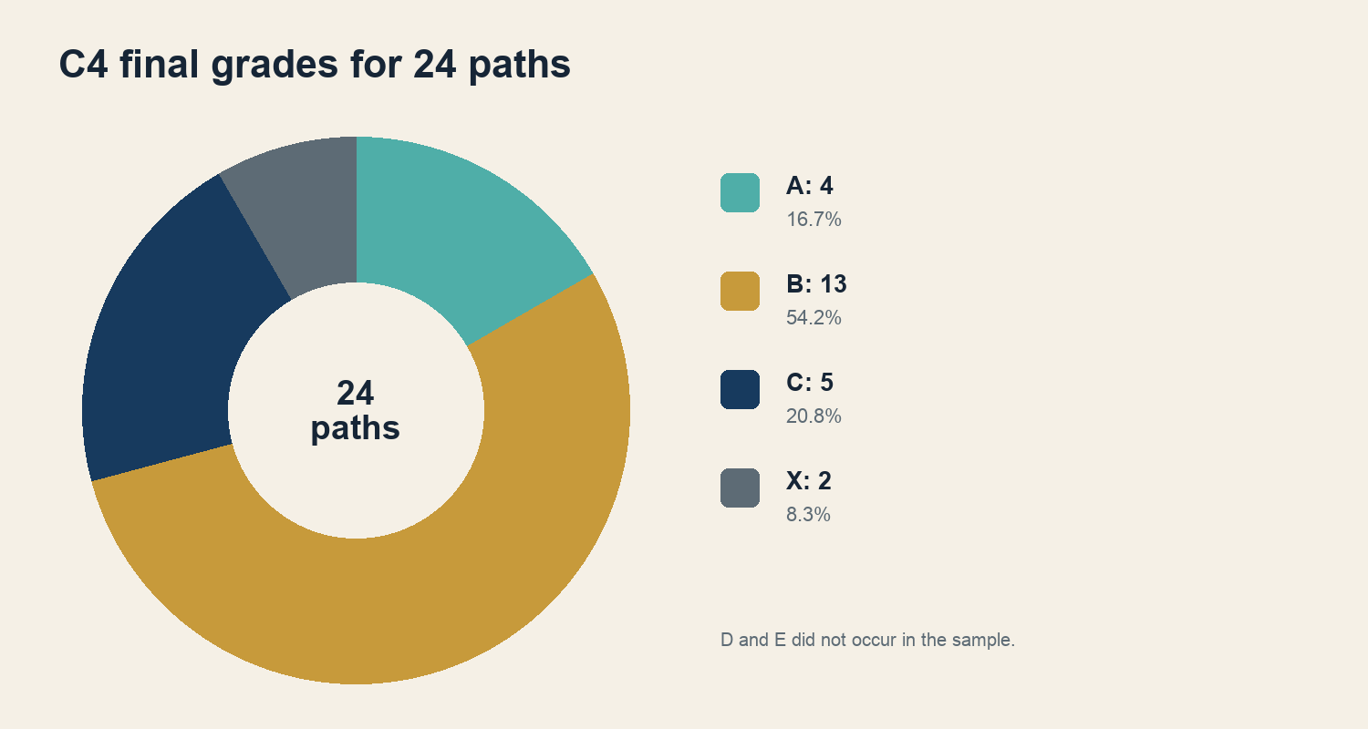
Fig. 4 · Final grades of all 24 qualifying translation paths.
A remained limited to four microtext-bound relations. B is the modal grade. Both X cases belong to CP-011 and mark deliberately unresolved evidence, not semantic emptiness.

18 Gate C5 adversarial review
Six explicitly nonhuman roles challenged all twelve cases and 24 final codes for stronger equivalents, counterexamples, period shifts, intradisciplinary changes, Eurocentric reductions, and rights or edition errors. No C4 code required revision.
Role | Focus
historical German philology | form and concept history
French and English lexicography | dating and semantic field
translation studies | unit, criterion, and function
adversarial methods review | falsification and counterevidence
rights and edition | access, page, and reuse
language and cultural critique | bounded substitute review for CP-011/012

19 Gate C6 research synthesis
C6 connects the dossiers without flattening their differences. Polysemy distribution is the most frequent mechanism, but institutional embedding, historical sedimentation, disciplinary history, word formation, and translation chains each explain distinct subsets. No mechanism class accounts for every case.
Comparison | Result
Cassin structure versus independent evidence | material divergence in CP-004, CP-008, CP-011, and CP-012
Within-pair variation | 9/12
Contextualisation or revision | 7/12 · 58.3%
open X case | CP-011

20 Hypothesis assessment
Hypothesis | Verdict | Supported finding
H1 | supported | Translation relations branch contextually; only 4 of 24 paths reach A.
H2 | supported | Word history and morphology explain only part of the result; U2, U5, U6, and U7 add further differences.
H3 | strongly supported | Same-passage comparisons reveal more than isolated dictionary equations; seven groups differ in grade.
H4 | supported | The German Atlas term is one coordinate among several, not a superordinate original.
H5 | supported | Missing Cassin coverage is first a corpus and reach finding.
H6 | not tested | No reproducible machine-translation series was conducted.

H6 Machine-translation data that were not collected are presented as neither confirmation nor refutation.

21 CP-001 Translation concept profile
ATLAS ANCHOR AT-CORE-239-069 · retain_with_research_context
The case examines translation as a directed practice among author, text, and reader. The historical dictionary layer for übersetzen, übertragen, and translatio shows a shared transfer schema but no linear chain of synonymous words.
Layer | FR2004 | EN2014
Cassin structure | direct_entry | direct_entry
Case group | A | A

Source basis
Schleiermacher's academy lecture of 1813/1816 provides the primary anchor. Bartscht's English version and Berman's French translation in the 1999 Seuil edition form the comparison targets. The French passage is text-direct and edition-triangulated but not checked against a facsimile.

Binding distinctions
• transfer metaphor and concrete translation method
• word equation and propositional adequacy
• lexical correspondence and relational structure
C2 MEANING The Cassin classification describes the checked edition structure. It decides neither the concept itself nor the Atlas definition.

21 CP-001 translation comparison and countermodel

Predeclared single criterion
Preservation of the author-reader movement in the bounded Schleiermacher sentence.
Path | Published target | C4 final code
C3-TRN-0001 | Bartscht 1992 EN | B · U2
C3-TRN-0007 | Berman 1999 FR | B · U2

Explicit countermodel
Jakobson supplies the countermodel: the absence of full equivalence between code units does not rule out adequate interpretation of messages, while poetic form may require creative transposition.

C6 finding and Atlas consequence
Both targets preserve the movement while redistributing rest, direction, and encounter idiomatically. The Atlas anchor remains sound if transfer is treated as one model among interpretation, recoding, and practice.

Open limits
• Berman 1999 not checked in facsimile
• modern translations limited to short quotation
• no human review

22 CP-002 Untranslatability concept profile
ATLAS ANCHOR AT-TRA-0001 · retain_as_is
Untranslatability is tested as a parameterised limit: form, function, historical layering, and genre may be preserved to different degrees. The case avoids equating non-identity with absolute impossibility.
Layer | FR2004 | EN2014
Cassin structure | translation_cluster | translation_cluster
Case group | A | A

Source basis
Humboldt's 1796 letter to Schlegel, historical German forms, and early French and English lexicography form S2/S3. S4 compares Benjamin's sentence on translatability in Zohn 1968 and Rendall 1997.

Binding distinctions
• the property of translatability and the act of translation
• cultural unsubstitutability and linguistic translatability
• early attestation and absolute origin claim
C2 MEANING The Cassin classification describes the checked edition structure. It decides neither the concept itself nor the Atlas definition.

22 CP-002 translation comparison and countermodel

Predeclared single criterion
Explicit preservation of translatability as a property of certain works.
Path | Published target | C4 final code
C3-TRN-0003 | Zohn 1968 EN | A · U4
C3-TRN-0004 | Rendall 1997 EN | C · U3

Explicit countermodel
Apter politically extends Cassin's programme but is not an independent countermodel. Des Rochers and Twiss provide the opposing position: translation is contextual interpretation, and cultural unsubstitutability can coexist with translatability.

C6 finding and Atlas consequence
Zohn preserves the property level; Rendall shifts it toward the act. The Atlas definition remains sound because it identifies the absence of lossless formal and functional identity rather than absolute impossibility.

Open limits
• no absolute first-attestation claim
• modern translations limited to short quotation
• no general theory of all texts

23 CP-003 Equivalence concept profile
ATLAS ANCHOR AT-W3-0296 · retain_as_is
Equivalence is not used as unspecified sameness. Every finding must state its relata, granularity, invariant, context, and strength. Nida and Catford already show different comparison units within translation studies.
Layer | FR2004 | EN2014
Cassin structure | translation_cluster | translation_cluster
Case group | A | A

Source basis
S4 uses Nietzsche's equivalence of damage and pain in the 1892 edition and the public-domain translations by Henri Albert in 1900 and Horace B. Samuel in 1921.

Binding distinctions
• identity and non-identical commensurability
• formal correspondence and textual equivalence
• local criterion and overall quality
C2 MEANING The Cassin classification describes the checked edition structure. It decides neither the concept itself nor the Atlas definition.

23 CP-003 translation comparison and countermodel

Predeclared single criterion
Preservation of the compensatory relation between damage and pain.
Path | Published target | C4 final code
C3-TRN-0005 | Albert 1900 FR | A · U2
C3-TRN-0006 | Samuel 1921 EN | B · U2

Explicit countermodel
The functionalist Skopos model associated with Vermeer and Nord replaces equivalence as a universal prior rule with an explicit brief, target audience, and target-text function. Local equivalence remains a possible outcome.

C6 finding and Atlas consequence
Both translations preserve the comparative relation, but injury narrows Schaden. Within the pilot's scope, the Atlas anchor is already sufficiently relational and requires no special change.

Open limits
• no ranking of whole translations
• historical briefs only partly reconstructable
• equivalence criteria not homogenised

24 CP-004 False friend concept profile
ATLAS ANCHOR AT-W3-0299 · retain_with_research_context
The case separates interlingual false friends, intralingual diachronic semantic change, and etymological false cognates. Formal similarity alone decides none of these classes.
Layer | FR2004 | EN2014
Cassin structure | translation_cluster | translation_cluster
Case group | B | B

Source basis
Bayle's lieu commun of 1727 is compared with an English translation from 1708 in its editorially amended 2005 form and with the English Cassin version of 2014.

Binding distinctions
• interlingual false friend
• diachronic shift within one language
• mere formal similarity without etymological relation
C2 MEANING The Cassin classification describes the checked edition structure. It decides neither the concept itself nor the Atlas definition.

24 CP-004 translation comparison and countermodel

Predeclared single criterion
Preservation of the historical argumentative topos, not merely the modern cliché reading.
Path | Published target | C4 final code
C3-TRN-0008 | 1708 / 2005 EN | B · U4
C3-TRN-0009 | Cassin 2014 EN | C · U4 U6

Explicit countermodel
A distributed connectionist model of cognates and interlingual homographs shows task-dependent processing. It limits static pair lists as a complete theory without removing their lexicographic value.

C6 finding and Atlas consequence
The historical version keeps the topos visible; EN2014 activates the cliché reading more strongly in the microtext. The Atlas anchor should be read with diachronic and typological context.

Open limits
• silent 2005 editorial amendment
• Cassin's commentary repairs the microtext only outside it
• processing experiment is not a complete theory of the lexicon

25 CP-005 Hermeneutics concept profile
ATLAS ANCHOR AT-W3-0314 · retain_with_research_context
In the sample, hermeneutics spans ancient vocabularies of interpretation, the general art of understanding, and later ontological or critical models. These layers must not be projected backwards as one stable concept.
Layer | FR2004 | EN2014
Cassin structure | cross_reference | cross_reference
Case group | B | B

Source basis
Plato, Aristotle, and Schleiermacher form the primary layer. S4 compares the opening sentence of Hermeneutics and Criticism from 1838 in the English versions by Bowie 1998 and Glebe/GHI.

Binding distinctions
• special and general hermeneutics
• methodological, human-scientific, and ontological models
• understanding and explanation of systematic distortion
C2 MEANING The Cassin classification describes the checked edition structure. It decides neither the concept itself nor the Atlas definition.

25 CP-005 translation comparison and countermodel

Predeclared single criterion
Preservation of the contrast between an absent general hermeneutics and existing special hermeneutics.
Path | Published target | C4 final code
C3-TRN-0010 | Bowie 1998 EN | A · U6
C3-TRN-0011 | Glebe GHI EN | B · U6

Explicit countermodel
Habermas limits the universality of philosophical hermeneutics: factual consensus may be false consensus under systematically distorted communication. Understanding then requires causal explanation and ideology critique.

C6 finding and Atlas consequence
Both targets preserve the sentence core; Glebe profiles general hermeneutics more strongly as comprehensive scope. The Atlas anchor remains sound but needs historical contextualisation.

Open limits
• Schleiermacher, Dilthey, Heidegger, and Gadamer not homogenised
• Habermas is a supplement and critique, not a total rejection
• modern texts limited to short quotation

26 CP-006 Intentionality concept profile
ATLAS ANCHOR AT-103-027 · revision_candidate_research_only
The case consistently separates intention, intentionality, and intensionality. Aquinas's intentio does not automatically denote Brentano's mark of the mental, and logical intensionality is not a variant of mental directedness.
Layer | FR2004 | EN2014
Cassin structure | cross_reference | cross_reference
Case group | B | B

Source basis
Aquinas, Brentano, and Husserl form the conceptual-historical axis. S4 compares Aquinas's explanation of intentio with the 1920 English Dominican translation and Schneider's German version of 1886-1892.

Binding distinctions
• ordinary intention
• mental directedness
• logical-semantic intensionality
C2 MEANING The Cassin classification describes the checked edition structure. It decides neither the concept itself nor the Atlas definition.

26 CP-006 translation comparison and countermodel

Predeclared single criterion
Preservation of explicitly marked directedness toward something.
Path | Published target | C4 final code
C3-TRN-0012 | Dominican 1920 EN | B · U3 U6
C3-TRN-0013 | Schneider DE | B · U2 U3

Explicit countermodel
Dennett's model of intentional systems relates intentionality to an explanatory and predictive strategy. It does not prove intrinsic mental states and does not remove the practical explanatory value of the intentional stance.

C6 finding and Atlas consequence
Both targets preserve the directional figure, but only within the Thomistic sentence. The Atlas anchor is a revision candidate because its wording may conflate the separate fields.

Open limits
• no backward projection of modern terminology
• Dennett not reduced to eliminativism
• revision is research-only

27 CP-007 Doxa concept profile
ATLAS ANCHOR AT-OXD-0001 · revision_candidate_research_only
Depending on the corpus, doxa denotes epistemic opinion, accepted validity, reputation, appearance, or prereflective practical adherence. Endoxa, opinion, and falsehood are not interchangeable subcases.
Layer | FR2004 | EN2014
Cassin structure | direct_entry | direct_entry
Case group | C | C

Source basis
Plato's Republic V 477e-478a and Aristotle's Topics provide two distinct ancient models. S4 compares the Platonic non-identity of doxa and episteme in Jowett 1892 and Chambry 1933.

Binding distinctions
• doxa and episteme
• doxa and endoxa
• explicit opinion and prereflective validity
C2 MEANING The Cassin classification describes the checked edition structure. It decides neither the concept itself nor the Atlas definition.

27 CP-007 translation comparison and countermodel

Predeclared single criterion
Preservation of the categorical non-identity of doxa and episteme in the local exchange.
Path | Published target | C4 final code
C3-TRN-0014 | Jowett 1892 EN | B · U2
C3-TRN-0015 | Chambry 1933 FR | B · U2

Explicit countermodel
Bourdieu's praxeological doxa denotes prereflective practical adherence to the social world. It cannot be reduced to an explicit opinion or a false proposition.

C6 finding and Atlas consequence
Both translations preserve the local opposition but do not exhaust the historical semantic fields. The Atlas anchor is a revision candidate because its emphasis on opinion is too narrow.

Open limits
• Bourdieu pages not read as a continuous full text
• ancient and modern doxa not identified
• no human specialist review

28 CP-008 Aporia concept profile
ATLAS ANCHOR AT-METZ1-0009 · retain_as_is
Aporia is separated into three axes: perplexity to be worked through methodically, logically or philosophically insoluble non-passage, and rhetorically staged hesitation. A lexical finding must not collapse these axes.
Layer | FR2004 | EN2014
Cassin structure | translation_cluster | unverified_present_not_cluster_qualified
Case group | C | C

Source basis
Aristotle's Metaphysics B 1 and Quintilian's rhetorical treatment form the primary layer. S4 compares Aristotle 995a24-b4 in Tredennick 1933 and Bonitz 1890.

Binding distinctions
• methodological perplexity
• logical or philosophical insolubility
• rhetorical aporia
C2 MEANING The Cassin classification describes the checked edition structure. It decides neither the concept itself nor the Atlas definition.

28 CP-008 translation comparison and countermodel

Predeclared single criterion
Preservation of working through aporiai as a condition of later insight or solution.
Path | Published target | C4 final code
C3-TRN-0016 | Tredennick 1933 EN | C · U2
C3-TRN-0017 | Bonitz 1890 DE | B · U2

Explicit countermodel
Derrida's aporia as non-passage or impossibility limits the assumption that every aporia is methodically solvable. The countermodel is not a reduction to formal contradiction or rhetorical dubitatio.

C6 finding and Atlas consequence
Bonitz preserves the methodological function through doubt and solution more explicitly; Tredennick profiles pragmatic removal. The Atlas anchor remains sound within the pilot's scope.

Open limits
• EN2014 structure not confirmed as a qualifying cluster
• Derrida checked only on key pages
• no overall ranking of translations

29 CP-009 Gift concept profile
ATLAS ANCHOR AT-CORE-239-018 · retain_as_is
The case separates socially institutionalised giving, delayed counter-gift, and the aporetic condition of a pure gift. The same vocabulary therefore supports models at different explanatory scales.
Layer | FR2004 | EN2014
Cassin structure | cross_reference | cross_reference
Case group | C | C

Source basis
Mauss and Malinowski form the social-anthropological basis. S4 compares the opening sentence of Mauss's Essai sur le don in the English translations by Halls 1990/2002 and Guyer 2016.

Binding distinctions
• gift as social prestation and present
• reception and obligatory return
• social practice and pure gift
C2 MEANING The Cassin classification describes the checked edition structure. It decides neither the concept itself nor the Atlas definition.

29 CP-009 translation comparison and countermodel

Predeclared single criterion
Explicit preservation of obligatory return in the isolated sentence.
Path | Published target | C4 final code
C3-TRN-0018 | Halls 1990 2002 EN | A · U5
C3-TRN-0019 | Guyer 2016 EN | C · U5

Explicit countermodel
Derrida's pure gift stands outside reciprocity, exchange, counter-gift, and debt. It does not refute Mauss's empirical social form but posits a different, aporetic condition.

C6 finding and Atlas consequence
Halls makes reciprocity explicit; Guyer names obligatory giving and receiving in the isolated sentence. The Atlas anchor remains sound as long as the explanatory scales remain separate.

Open limits
• Mauss edition and modern translations retain rights reservations
• the following sentence does not retroactively repair the microtext
• pure gift is not an empirical counterexample

30 CP-010 Identity concept profile
ATLAS ANCHOR AT-CORE-238-040 · retain_with_research_context
Identity is separated into numerical identity, personal continuity, selfhood, and social production of identity. The case prevents Locke's consciousness criterion from being treated as a complete theory of all identity concepts.
Layer | FR2004 | EN2014
Cassin structure | direct_entry | direct_entry
Case group | D | D

Source basis
Aristotle, Locke, and Stuart Hall provide three distinct models. S4 compares Locke II.xxvii.9 in Coste's French translation of 1700 and Poley's German translation of 1757.

Binding distinctions
• numerical identity
• consciousness-bound personal continuity
• selfhood and social positioning
C2 MEANING The Cassin classification describes the checked edition structure. It decides neither the concept itself nor the Atlas definition.

30 CP-010 translation comparison and countermodel

Predeclared single criterion
Preservation of personal identity constituted and temporally bounded by consciousness.
Path | Published target | C4 final code
C3-TRN-0020 | Coste 1700 FR | B · U3 U7
C3-TRN-0021 | Poley 1757 DE | B · U4

Explicit countermodel
Reid treats memory as evidence of a prior numerical identity, not as its constitution. His transitivity objection targets a direct memory theory but not necessarily every nuanced reading of Locke.

C6 finding and Atlas consequence
Coste marks a terminological coinage with con-science; Poley's Einerleyheit is historically bounded. The Atlas anchor remains sound but needs context for the different axes of identity.

Open limits
• Reid does not refute every interpretation of Locke
• historical target words not modernised
• social identity production not tested by Reid

31 CP-011 Ubuntu concept profile
ATLAS ANCHOR AT-119-046 · retain_as_is_with_unresolved_review
Ubuntu is not evidenced as an examined structure in FR2004 or EN2014. Independent evidence separates the lexeme, Nguni form series, proverb, relational personhood, and normative reconstructions.
Layer | FR2004 | EN2014
Cassin structure | absent_from_checked_editions | absent_from_checked_editions
Case group | D | D

Source basis
Historical lexicography, the South African TRC report, Gade, Dladla, Metz, and Eze form the evidence base. Ramose remains central but has not been secured through passage-specific full-text verification.

Binding distinctions
• ubuntu as a lexeme
• umuntu ngumuntu ngabantu as a proverb
• relational personhood and majority obedience
C2 MEANING The Cassin classification describes the checked edition structure. It decides neither the concept itself nor the Atlas definition.

31 CP-011 translation comparison and countermodel

Predeclared single criterion
Preservation of the shift from singular person to relational plural form.
Path | Published target | C4 final code
C3-TRN-0022 | TRC EN | X · U5
C3-TRN-0023 | Eze UNESCO EN | X · U5

Explicit countermodel
Eze rejects the claim that relational personhood necessarily places community above individual autonomy. Relation includes equality, uniqueness, and difference; neither individual nor community has automatic priority.

C6 finding and Atlas consequence
The formal person structure can be described, but its nga semantics and philosophical force are not sufficiently secured. Both paths remain X. The Atlas anchor is unchanged and carries an unresolved review reservation.

Open limits
• no human Nguni-language review
• no human African-philosophy review
• Ramose 1999 not checked passage-specifically in full text

32 CP-012 Omotenashi concept profile
ATLAS ANCHOR AT-CORE-243-023 · revision_candidate_research_only
Omotenashi is absent from both checked Cassin editions. The case separates historical practice, modern institutional standardisation, tourist self-presentation, and the claim of a unique Japanese word.
Layer | FR2004 | EN2014
Cassin structure | absent_from_checked_editions | absent_from_checked_editions
Case group | D | D

Source basis
Takigawa's French IOC presentation of 2013 is compared with a 2016 English Yokkaichi version and Pellicanò's published English rendering from 2019. No official stenographic IOC transcript was established.

Binding distinctions
• practice and national representation
• lexicography and promotional speech
• historical variability and timeless essential claim
C2 MEANING The Cassin classification describes the checked edition structure. It decides neither the concept itself nor the Atlas definition.

32 CP-012 translation comparison and countermodel

Predeclared single criterion
Explicit preservation of the rhetorical claim that there is one Japanese word.
Path | Published target | C4 final code
C3-TRN-0024 | Yokkaichi 2016 EN | B · U5 U7
C3-TRN-0025 | Pellicanò 2019 EN | C · U5 U7

Explicit countermodel
Pellicanò analyses the speech as self-orientalising national representation. Exclusivity is constructed in the institutional presentation rather than confirmed as a timeless lexical fact.

C6 finding and Atlas consequence
One version preserves the one-word claim and the other omits it. This tests rhetoric, not Japanese uniqueness. The Atlas anchor is a revision candidate because its formulation of anticipated needs is too historically rigid.

Open limits
• no official stenographic IOC transcript
• no human Japanese-language or cultural-studies review
• no claim of lexical uniqueness

33 Comparison of the twelve cases
Case | Concept | FR2004 / EN2014 | C4 | Atlas consequence
CP-001 | Translation | direct_entry / direct_entry | B · U2 / B · U2 | retain_with_research_context
CP-002 | Untranslatability | translation_cluster / translation_cluster | A · U4 / C · U3 | retain_as_is
CP-003 | Equivalence | translation_cluster / translation_cluster | A · U2 / B · U2 | retain_as_is
CP-004 | False friend | translation_cluster / translation_cluster | B · U4 / C · U4 U6 | retain_with_research_context
CP-005 | Hermeneutics | cross_reference / cross_reference | A · U6 / B · U6 | retain_with_research_context
CP-006 | Intentionality | cross_reference / cross_reference | B · U3 U6 / B · U2 U3 | revision_candidate_research_only
CP-007 | Doxa | direct_entry / direct_entry | B · U2 / B · U2 | revision_candidate_research_only
CP-008 | Aporia | translation_cluster / unverified_present_not_cluster_qualified | C · U2 / B · U2 | retain_as_is
CP-009 | Gift | cross_reference / cross_reference | A · U5 / C · U5 | retain_as_is
CP-010 | Identity | direct_entry / direct_entry | B · U3 U7 / B · U4 | retain_with_research_context
CP-011 | Ubuntu | absent_from_checked_editions / absent_from_checked_editions | X · U5 / X · U5 | retain_as_is_with_unresolved_review
CP-012 | Omotenashi | absent_from_checked_editions / absent_from_checked_editions | B · U5 U7 / C · U5 U7 | revision_candidate_research_only

The table is a navigation matrix. Full reasons and reservations appear in the case dossiers and dataset.

34 Distribution of difference mechanisms
Mechanism | Paths | Observation
U1 | 0 | no isolated lexical gap as a final mechanism
U2 | 9 | most frequent form of context-dependent redistribution
U3 | 4 | word formation and interpretation of names
U4 | 4 | historical sedimentation
U5 | 6 | institutional and social embedding
U6 | 4 | diachronic or disciplinary shift
U7 | 3 | coinage and multi-stage transmission

The sum exceeds 24 because individual paths may carry several evidenced mechanisms. The table describes occurrence, not causal strength.

35 Cassin and independent evidence
In the pilot, Cassin is a productive atlas of problems but not a complete inventory of Atlas concepts. Direct entries do not create automatic conceptual identity; cross-references are not weaker truths; clusters show distributed treatment; absence describes the reach of the checked editions.
Divergence case | Reason
CP-004 | historical topos and modern cliché reading
CP-008 | structural difference between FR2004 and EN2014
CP-011 | corpus absence with substantial independent evidence and open review
CP-012 | corpus absence with an institutionally constructed one-word claim

36 Atlas anchors as a research finding
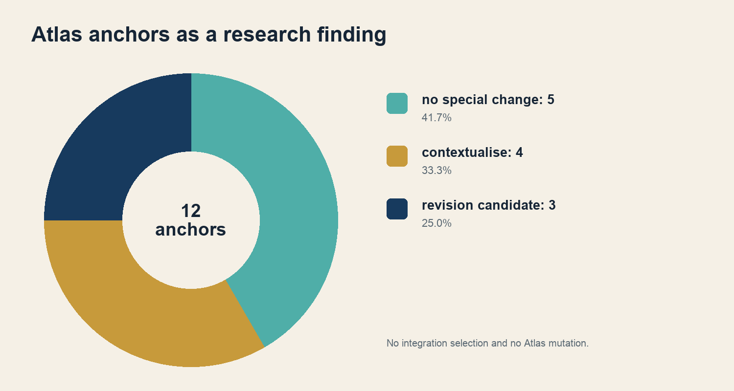
Fig. 5 · Five anchors remain, four require context, and three are revision candidates.
The three revision candidates are Intentionality, Doxa, and Omotenashi. The four contextual cases are Translation, False friend, Hermeneutics, and Identity. This classification creates neither amendment text nor integration packages.

37 Limitations and mandatory reservations
1. No human, native-speaker, cultural-insider, or personally independent reviews were conducted.
2. CP-011 remains open for Nguni semantics and African-philosophy assessment; both paths remain X/U5.
3. CP-012 tests only French-English presentation rhetoric; Japanese uniqueness is not established.
4. FR2019 is not part of the digital comparison corpus.
5. Rights, access, edition, and facsimile reservations remain source-specific.
6. The documented public Atlas mismatch of 1,028/1,024 remains a separate blocker for integration and publication.
7. H6 was not tested.

Methods appendix A workflow
Step | Input | Output
C0 | editions and access | bibliographic and rights baseline
C1 | canonical Atlas data | twelve read-back anchors
C2 | FR2004 · EN2014 | twelve structural classes
C3 | sources, lexica, passages, countermodels | twelve completed dossiers
C4 | 24 frozen evidence cards | 24 final codes
C5 | final codes and reservations | adversarial bounded pass
C6 | all dossiers | synthesis and hypothesis verdict
C7 | frozen C6 state | report, dataset, manifest

Methods appendix B evidence registers
Register | Primary key | Purpose
CASSIN_Quellenregister_C3.jsonl | source_id | work, edition, language, and locator
CASSIN_Rechteregister_C3.jsonl | rights_id | research access and reuse
CASSIN_Passagenregister_C3.jsonl | passage_id | excerpt, word count, and group binding
CASSIN_Uebersetzungswege_C3.jsonl | translation_path_id | directed passage-to-passage relation
CASSIN_Negativbefunde_C3.jsonl | negative_finding_id | rejected equations and limits
CASSIN_Simulationsregister_C3.jsonl | simulation_review_id | nonhuman review roles

The C7 dataset joins the 24 qualifying C3 paths to the final C4 codes and C6 case closures. It does not overwrite the source registers.

Methods appendix C rights review
1. Establish work and edition identity.
2. Check author and translator status separately.
3. Separate text rights, digitisation, transcription, and platform terms.
4. Do not present research access as an open licence.
5. Store only necessary short quotations for protected texts.
6. Recheck every later publication at object level.
RESULT The 164 sources map to 164 rights objects; no stored protected passage exceeds 25 words.

Methods appendix D coding and adjudication
The C4 unit is the individual published translation path. Each run assigns exactly one grade and at least one mechanism. The adjudicator checks the reasons against frozen evidence. A mechanism is retained only when evidenced for that particular path.
Decision state | Rule
grade agreement | accept only with adequate reasons
grade dissent | no averaging; evidence decides
mechanism dissent | evidence or reject codes individually
unresolved | X
rights question | not changed by semantic code

Methods appendix E simulation review
Because human resources were unavailable, historical philology, lexicography, translation studies, adversarial review, and rights review were simulated as separate model roles. CP-011 and CP-012 added a bounded language and cultural critique role. The simulations are procedures for systematic counter-reading, not people or speaker judgements.
Permitted state | Meaning
pass | no decisive objection within the permitted evidence frame
pass_with_reservations | finding remains with visible limits
bounded_pass_with_unresolved_human_review | nonhuman review complete; human gap remains
stop | evidence, rights, or method insufficient

Case register
ID | Concept | Atlas ID | FR2004 | EN2014 | C6 consequence
CP-001 | Translation | AT-CORE-239-069 | direct_entry | direct_entry | retain_with_research_context
CP-002 | Untranslatability | AT-TRA-0001 | translation_cluster | translation_cluster | retain_as_is
CP-003 | Equivalence | AT-W3-0296 | translation_cluster | translation_cluster | retain_as_is
CP-004 | False friend | AT-W3-0299 | translation_cluster | translation_cluster | retain_with_research_context
CP-005 | Hermeneutics | AT-W3-0314 | cross_reference | cross_reference | retain_with_research_context
CP-006 | Intentionality | AT-103-027 | cross_reference | cross_reference | revision_candidate_research_only
CP-007 | Doxa | AT-OXD-0001 | direct_entry | direct_entry | revision_candidate_research_only
CP-008 | Aporia | AT-METZ1-0009 | translation_cluster | unverified_present_not_cluster_qualified | retain_as_is
CP-009 | Gift | AT-CORE-239-018 | cross_reference | cross_reference | retain_as_is
CP-010 | Identity | AT-CORE-238-040 | direct_entry | direct_entry | retain_with_research_context
CP-011 | Ubuntu | AT-119-046 | absent_from_checked_editions | absent_from_checked_editions | retain_as_is_with_unresolved_review
CP-012 | Omotenashi | AT-CORE-243-023 | absent_from_checked_editions | absent_from_checked_editions | revision_candidate_research_only

REGISTER RULE The structure fields refer only to the checked editions; the Atlas consequence is research, not integration.

Translation path register 1
Path | Case | Concept | Target | Final code
C3-TRN-0001 | CP-001 | Translation | Bartscht 1992 EN | B · U2
C3-TRN-0007 | CP-001 | Translation | Berman 1999 FR | B · U2
C3-TRN-0003 | CP-002 | Untranslatability | Zohn 1968 EN | A · U4
C3-TRN-0004 | CP-002 | Untranslatability | Rendall 1997 EN | C · U3
C3-TRN-0005 | CP-003 | Equivalence | Albert 1900 FR | A · U2
C3-TRN-0006 | CP-003 | Equivalence | Samuel 1921 EN | B · U2
C3-TRN-0008 | CP-004 | False friend | 1708 / 2005 EN | B · U4
C3-TRN-0009 | CP-004 | False friend | Cassin 2014 EN | C · U4 U6
C3-TRN-0010 | CP-005 | Hermeneutics | Bowie 1998 EN | A · U6
C3-TRN-0011 | CP-005 | Hermeneutics | Glebe GHI EN | B · U6
C3-TRN-0012 | CP-006 | Intentionality | Dominican 1920 EN | B · U3 U6
C3-TRN-0013 | CP-006 | Intentionality | Schneider DE | B · U2 U3

Complete passage IDs, locators, observed shifts, adjudication reasons, and reservations appear in the C7 dataset.

Translation path register 2
Path | Case | Concept | Target | Final code
C3-TRN-0014 | CP-007 | Doxa | Jowett 1892 EN | B · U2
C3-TRN-0015 | CP-007 | Doxa | Chambry 1933 FR | B · U2
C3-TRN-0016 | CP-008 | Aporia | Tredennick 1933 EN | C · U2
C3-TRN-0017 | CP-008 | Aporia | Bonitz 1890 DE | B · U2
C3-TRN-0018 | CP-009 | Gift | Halls 1990 2002 EN | A · U5
C3-TRN-0019 | CP-009 | Gift | Guyer 2016 EN | C · U5
C3-TRN-0020 | CP-010 | Identity | Coste 1700 FR | B · U3 U7
C3-TRN-0021 | CP-010 | Identity | Poley 1757 DE | B · U4
C3-TRN-0022 | CP-011 | Ubuntu | TRC EN | X · U5
C3-TRN-0023 | CP-011 | Ubuntu | Eze UNESCO EN | X · U5
C3-TRN-0024 | CP-012 | Omotenashi | Yokkaichi 2016 EN | B · U5 U7
C3-TRN-0025 | CP-012 | Omotenashi | Pellicanò 2019 EN | C · U5 U7

Complete passage IDs, locators, observed shifts, adjudication reasons, and reservations appear in the C7 dataset.

Selected source register
The following selection identifies the principal work groups. The complete register contains 164 records and forms part of the reproducible project state.
Nr. | Source
1 | Cassin, Barbara (dir.) (2004): Vocabulaire européen des philosophies. Dictionnaire des intraduisibles. Paris: Seuil / Le Robert.
2 | Cassin, Barbara (ed.) (2014): Dictionary of Untranslatables. A Philosophical Lexicon. Princeton: Princeton University Press.
3 | Schleiermacher, Friedrich (1816): Ueber die verschiedenen Methoden des Uebersetzens. Berlin.
4 | Jakobson, Roman (1959): On Linguistic Aspects of Translation.
5 | Benjamin, Walter (1923): Die Aufgabe des Übersetzers. Heidelberg.
6 | Zohn, Harry (1968): The Task of the Translator. In Illuminations.
7 | Rendall, Steven (1997): The Translator's Task. TTR 10(2).
8 | Apter, Emily (2013): Against World Literature. London: Verso.
9 | Des Rochers, Arianne; Twiss, Robert (2018): Against Untranslatability. Quaderna 4.
10 | Nida, Eugene A. (1964): Toward a Science of Translating.
11 | Catford, J. C. (1965): A Linguistic Theory of Translation.
12 | Nord, Christiane (2016): Function plus Loyalty. Procedia 231.
13 | Nietzsche, Friedrich (1892): Zur Genealogie der Moral. 2. Auflage.
14 | Bayle, Pierre (1727): Oeuvres diverses. Band II.
15 | Schleiermacher, Friedrich; Lücke, Friedrich (1838): Hermeneutik und Kritik.
16 | Habermas, Jürgen (1970): The Hermeneutic Claim to Universality.
17 | Thomas Aquinas: Summa theologiae I-II, q. 12, a. 1.
18 | Brentano, Franz (1874): Psychologie vom empirischen Standpunkte.

Reproduction and dataset
1. Verify the C3 freeze against its stored manifest.
2. Verify the C4 and C5 manifests against the C6 baseline.
3. Load the C7 dataset and verify twelve unique pilot_id values and 24 unique translation_path_id values.
4. Check grade distribution A4, B13, C5, X2 and mechanisms U1-U7.
5. Build the reports with the stored builder from unchanged same-language references.
6. Render DOCX and PDF completely and check page count, text, tables, fonts, and hashes.
Dataset | Value
JSON | CASSIN_C7_Research_Dataset_v1_2026-09-13.json
CSV | CASSIN_C7_Research_Dataset_v1_2026-09-13.csv
Scope | 12 cases · 24 paths
JSON SHA-256 | 3c7eef8e03c294bce269e45db75ac9cf8446b416724363219fb96f8769a610a3

Reproduction manifest and hash chain
Stage | SHA-256
C3 freeze | fb398d187d9e565415094f631b252882f922b775b4994c28fc07ce5a18afe9cb
C4 final | 074f2c1e6a600c1c930c37997b9cb4eac8c86a0563a8057227a6ed25121b80a8
C5 final | ada06b8dc72bfefbb6abccd5bab3ce2a0788d98a3e093e81a96e7d42002a6272
C6 final | 4825e48627f3b7f354f5fd200a79f65644e9d5102a308b60c0676de5cccf6bda
C7 dataset | 3c7eef8e03c294bce269e45db75ac9cf8446b416724363219fb96f8769a610a3

After final rendering, the machine-readable C7 reproduction manifest extends this chain with SHA-256 values for both DOCX and PDF editions, the JSON and CSV datasets, the builder, and the QA file. The manifest contains no self-referential hash.
FREEZE BOUNDARY Any change to the report, dataset, or builder creates a new hash and requires a new version decision.

Citation references and transparency
CITE THE REPORT Reich, Michael (2026): Cassin and the Work of Untranslatability. Research report on twelve concept cases, 24 translation paths, and Gates C0 through C6. English edition, version 1.1. Atlas of Language / Atelier der Resonanzen, 13 September 2026.
CITE THE DATASET Reich, Michael (2026): Cassin Pilot Dataset on Non-equivalence and Untranslatability. Version 1.0. Atlas of Language / Atelier der Resonanzen, 13 September 2026.
• Husserl, Edmund (1901): Logische Untersuchungen. 2. Band.
• Dennett, Daniel C. (1971): Intentional Systems. Journal of Philosophy 68.
• Plato: Republic V 477e-478a.
• Aristotle: Topics I.1 and Metaphysics B 1.
• Bourdieu, Pierre (1977): Outline of a Theory of Practice.
• Derrida, Jacques (1993): Aporias.
• Mauss, Marcel (1925): Essai sur le don.
• Malinowski, Bronisław (1922): Argonauts of the Western Pacific.
• Derrida, Jacques (1992): Given Time I. Counterfeit Money.
• Locke, John (1700): An Essay Concerning Humane Understanding. 4th ed.
• Reid, Thomas (1785): Essays on the Intellectual Powers of Man.
• Hall, Stuart (1990): Cultural Identity and Diaspora.
• Gade, Christian B. N. (2011): The Historical Development of the Written Discourses on Ubuntu.
• Dladla, Ndumiso (2017): Here is a Table: A Philosophical Essay on History and Race in South Africa.
• Metz, Thaddeus (2011): Ubuntu as a Moral Theory and Human Rights in South Africa.
• Eze, Michael Onyebuchi (2018/2023): I am because you are. UNESCO.
• Pellicanò, Elisa Ivana (2019): Representing Japanese Hospitality. Journal of International and Advanced Japanese Studies 11.

Transparency
The resonance design organises the study visually. Resonance is not a measured variable. The reports were generated from the frozen research state and rendered in full; machine-readable registers remain authoritative for individual findings. Atlas integration, public approval, and deployment are not part of this report.
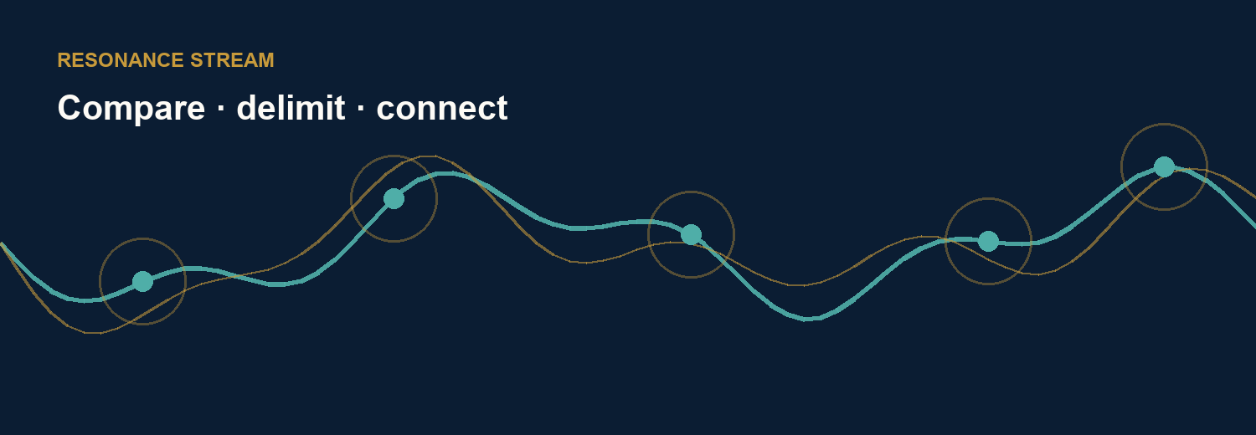
Closing image · Translation relates differences while keeping them visible.

