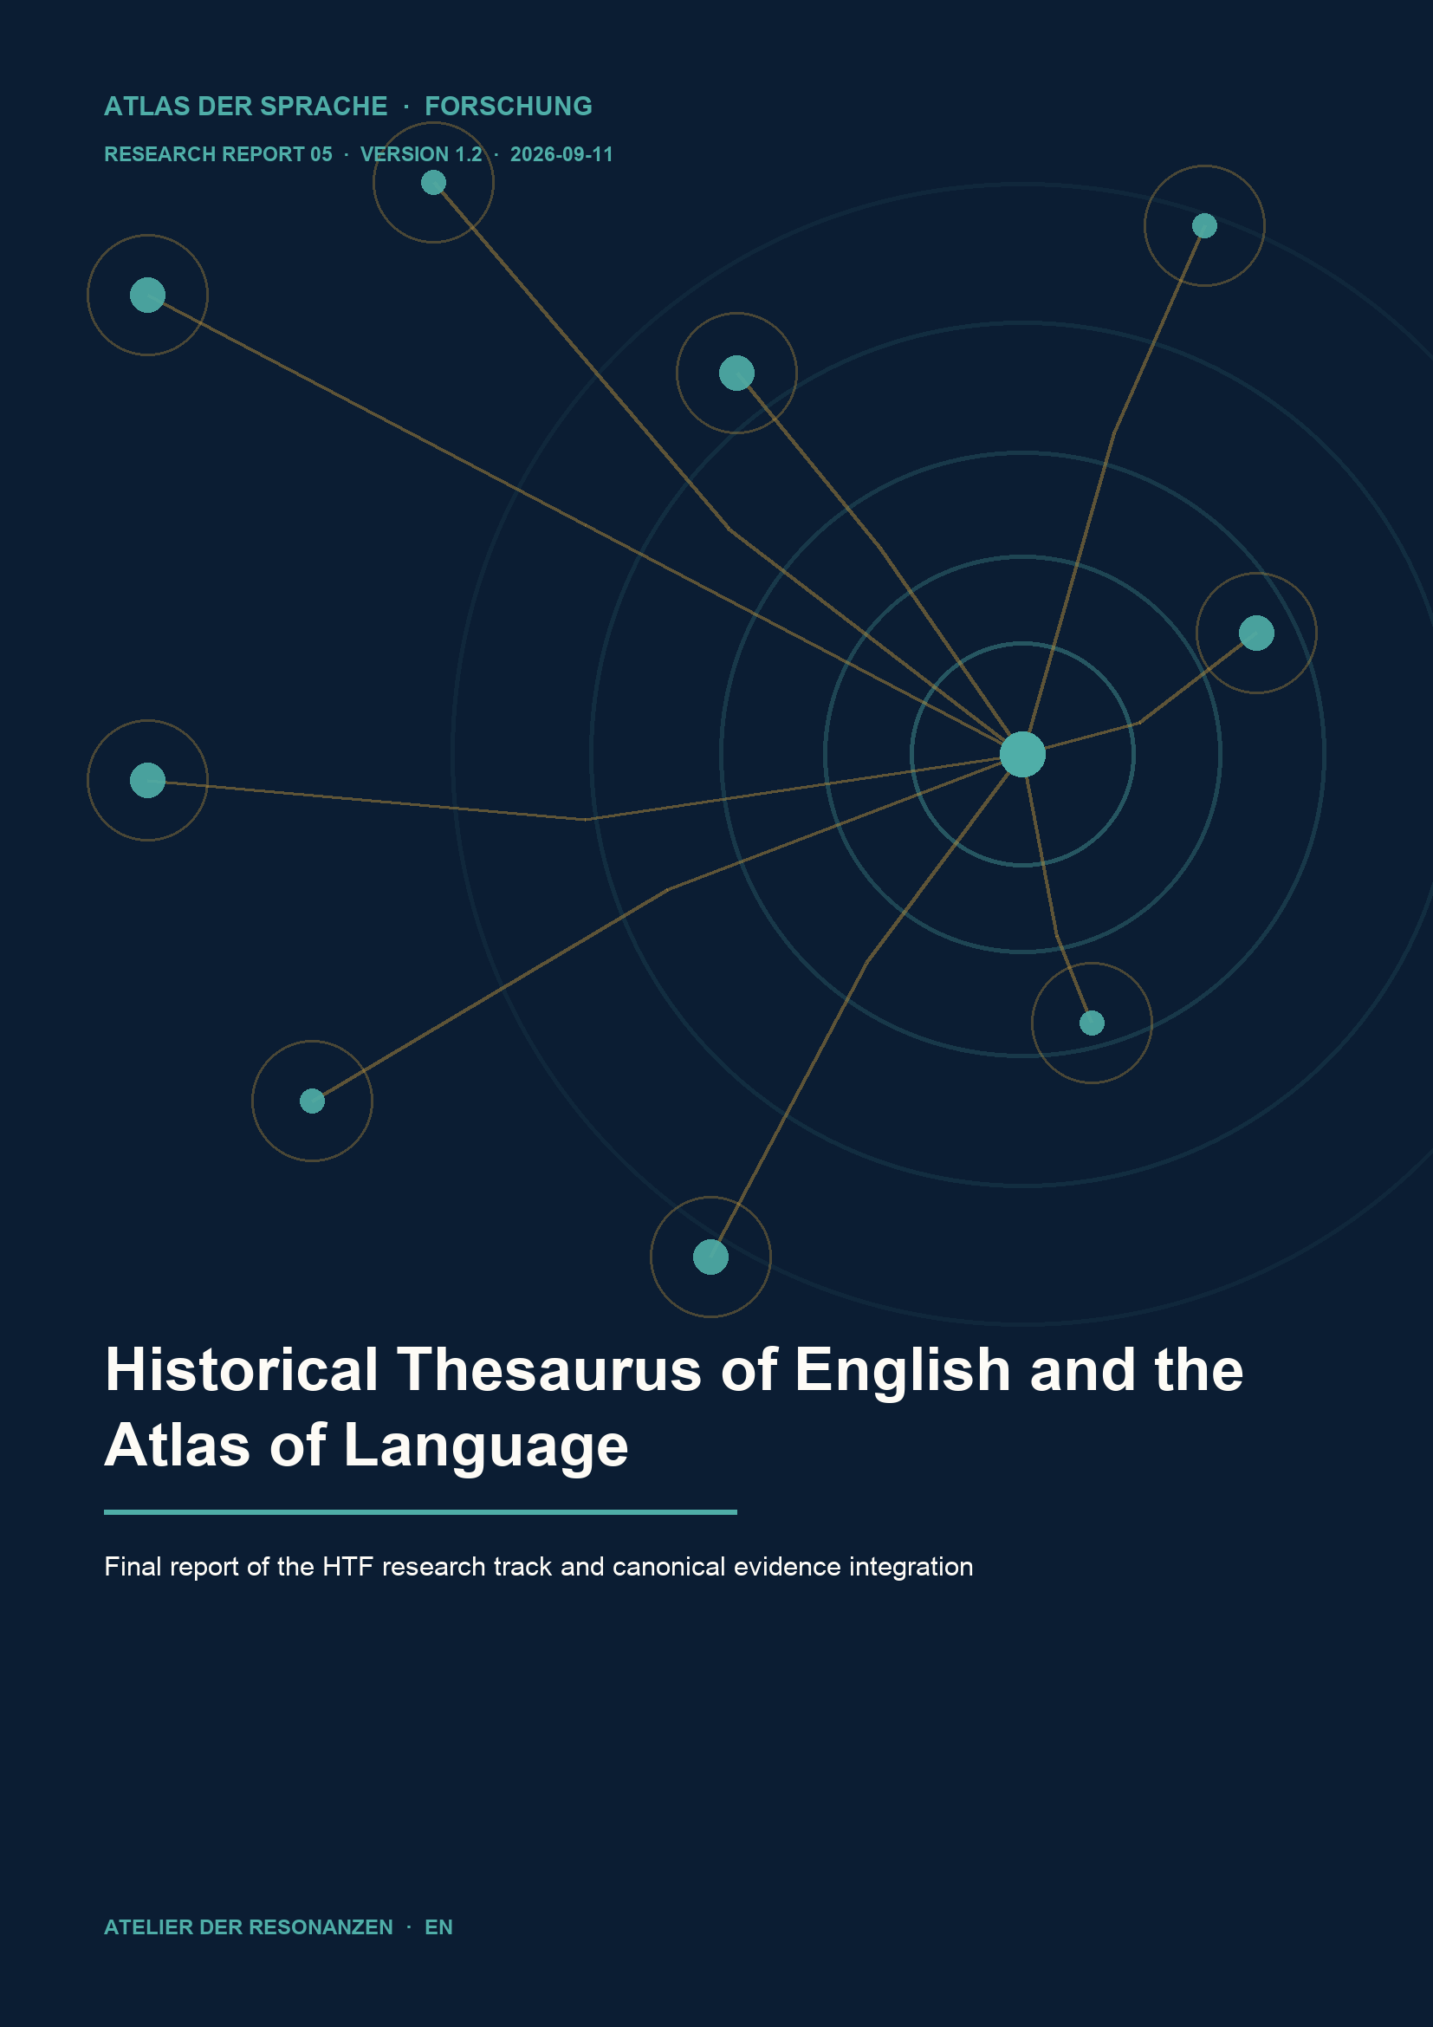

ENGLISH RESEARCH EDITION · VERSION 1.2

Historical Thesaurus of English and the Atlas of Language

  - Final report of the HTF research track and canonical evidence integration
Michael Reich · Atlas of Language · 11 September 2026

Abstract
The HTF research track investigates how the Historical Thesaurus of English (HTE) can serve as historical evidence for the Atlas of Language without equating the HTE semantic hierarchy with the Atlas internal ontology. A purposive pilot set of 28 Atlas concepts was researched against HTE version 5.0 and reviewed for scope, polysemy, recorded chronology and level of abstraction. A multi-stage AI review distinguished 21 accepted evidence links, four context-only findings and three documented negative findings. Among the 21 accepted cases, ten are direct mappings, four point to an HTE category broader than the Atlas concept and seven to a narrower HTE category. The controlled accepted import added only 21 evidence records. It changed no Atlas concepts, definitions, internal relations, translations or crosswalk layers. Evidence IDs 1719 through 1739 are bound to the unchanged package hash. Following the later WordNet consolidation, the complete HTE contribution persists in the current Atlas 9.0.0 readback: 21 HTE records within 1,739 evidence records overall. The research demonstrates that a historical thesaurus is particularly valuable as source-specific provenance and semantic-field evidence, provided direct correspondence, broader scope, narrower scope, contextual proximity and non-match remain separate decision classes.
Keywords: Historical Thesaurus of English; HTE; historical semantics; semantic change; evidence; scope; polysemy; controlled import; provenance; Atlas of Language.
Metric | Value
Selected pilot concepts | 28
Accepted HTE evidence records | 21
Context-only / negative findings | 4 / 3
Direct / HTE broader / HTE narrower | 10 / 4 / 7
Current evidence inventory | 1,739

REPORT PROFILE
Research: purposive pilot covering 28 Atlas concepts. Canonical read layer: 21 scope-typed HTE evidence records. Effect of this report: research closeout and documentation; no external publication.
PACKAGE BINDING
ATLAS-INBOX-HTE-PILOT-V1-EVIDENCE-0001
96d2a546a0fb13700ec3f63d8dcca9657394c32ca665be252347f488d1f36bb0

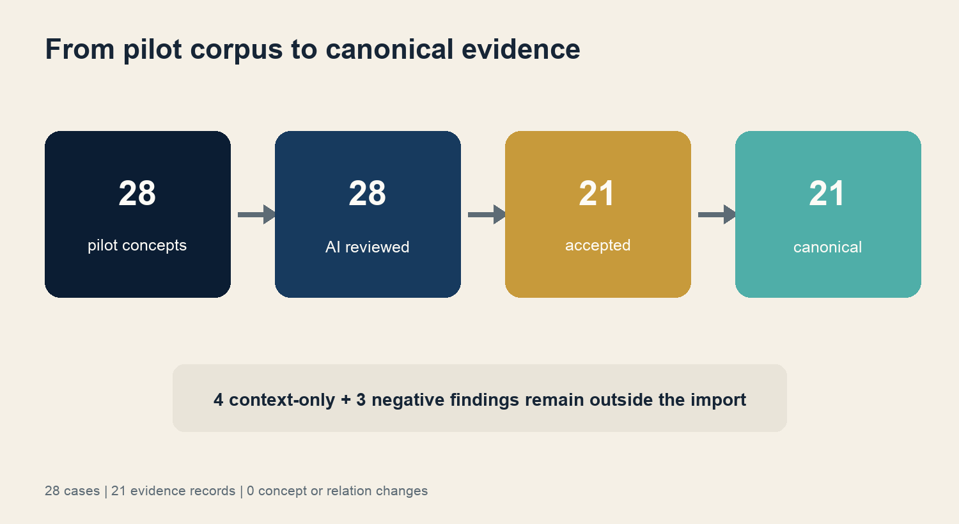
Fig. 1 From pilot corpus to canonical HTE evidence.

1 Research question and scope
The guiding question is: How can a historically organized English semantic resource strengthen the Atlas empirically without turning external categories into presumed Atlas identities? The pilot is neither a complete HTE survey nor a statistically representative sample. It is a methodological stress test using 28 deliberately diverse concepts from rhetoric, pragmatics, epistemology, narrative forms, literacy, morphology, syntax and translation.
Three layers remain separate throughout the project:
• Source layer: What does HTE version 5.0 actually document as a historical category or lexicalization?
• Interpretive layer: Does the external semantic field match the Atlas concept directly, is it broader or narrower, or does it provide context only?
• Canonical layer: Which reviewed claim may be added as evidence without changing Atlas identity or internal relations?
The project did not attempt to import the HTE classification, perform a bulk download, redefine Atlas concepts automatically, publish HTE raw data or claim that English lexical history represents cross-linguistic universals.

2 The external resource
HTE organizes the historical English lexicon onomasiologically, moving from semantic domains to linguistic expressions. Its current second edition, version 5.0, combines evidence from the Oxford English Dictionary and the Thesaurus of Old English. The official description lists approximately 235,249 categories and 804,830 entries under three major divisions: the external world, the mental world and the social world. Its hierarchy is semantic and prototypical; neighboring entries are not necessarily synonyms.
Feature | Relevance to the Atlas | Methodological consequence
Historical dates | Document recorded English usage | Do not treat dates as the origin of a universal concept
Polysemous lemmas | A word may occur in several categories | String equality is not identity evidence
Hierarchical categories | Broader and narrower regions are visible | Record scope direction explicitly
Versioned numbering | Categories and dates may be revised | Cite version 5.0 and access date
Persistent category URLs | Individual findings remain inspectable | Preserve URL and category in the evidence record
Terms of use | Non-commercial research and limited extracts | Do not replicate raw data; document small source-bound findings only

Following the official guidance, the resource is cited as the Historical Thesaurus of English, second edition, version 5.0, University of Glasgow, with current access date and version. Its persistent research data record is available at DOI 10.5525/gla.researchdata.2163.

3 Data and method

3 1 Pilot design
The 28 concepts were chosen purposively. The set combines likely historical anchors, abstract boundary cases and negative controls. This makes the procedure capable of demonstrating not just matches but also the conditions under which an import must not occur.
Review stage | Input | Decision criterion | Durable output
Selection | 28 Atlas concepts | thematic spread and risk cases | pilot-selection.jsonl
Source research | HTE v5.0 | category, path, date, URL | pilot-crosswalk.jsonl
Initial typing | 28 findings | direct, broader, narrower, context, negative | mapping proposal v0
AI review | all 28 cases | scope, polysemy, evidence text, false match | ai-expert-review-v1.jsonl
Owner gate | 21 positive cases | explicit evidence-only acceptance | accepted package
Dry-run and import | unchanged package | 21 additions, 0 duplicates, 0 conflicts | migration 0133
Readback | canonical export | package hash, IDs, counts, unresolved relations | verified final state

3 2 Multi-stage AI expert review
Because external human expert review is not economically feasible for this private project, a documented AI review was used as proportionate quality assurance. It simulated four separate perspectives: historical lexicography, semantic scope, data provenance and canonical integration safety. The AI had no authority to accept data. It revised three mapping types and downgraded four cases to context-only. Final acceptance of the 21 evidence records remained an explicit owner decision.
This procedure is not anonymous human peer review and is not represented as such. Its strength is reproducible review of every case, visible reasons for dissenting judgments and a clear boundary between recommendation and approval.

4 Results
Twenty-one of the 28 investigated Atlas concepts were accepted as canonical HTE evidence. Four findings provide useful research context but are not precise enough for an evidence link. Three concepts produced no defensible HTE anchor. The 75 percent acceptance rate describes this deliberately constructed pilot only and must not be extrapolated to the full Atlas.
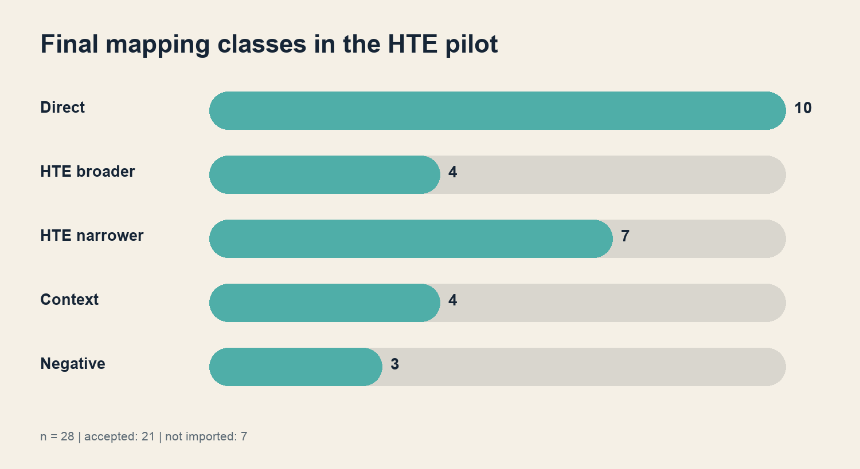
Fig. 2 Final distribution of mapping types.
Final class | Count | Share of pilot | Canonical effect
Direct | 10 | 35.7% | additive HTE evidence
HTE broader | 4 | 14.3% | additive evidence with scope warning
HTE narrower | 7 | 25.0% | additive evidence with scope warning
Context | 4 | 14.3% | research record, no import
Negative | 3 | 10.7% | documented non-match, no import
Total | 28 | 100% | 21 imported, 7 not imported

4 1 Accepted evidence cases
Atlas concept | Domain | Final type | Claim boundary
Metaphor | Rhetoric/stylistics | HTE narrower | HTE path supports a specific historical subregion
Irony | Rhetoric/stylistics | direct | defensible historical semantic anchor
Euphemism | Rhetoric/stylistics | direct | defensible historical semantic anchor
Hyperbole | Rhetoric/stylistics | direct | defensible historical semantic anchor
Metonymy | Pragmatics | HTE broader | external category exceeds the Atlas concept
Pun | Word play/language puzzles | direct | historical lexicalization as evidence
Question | Pragmatics/conversation | HTE broader | communicative field exceeds Atlas profile
Request | Pragmatics/conversation | direct | defensible action and semantic anchor
Gesture | Pragmatics/conversation | HTE broader | HTE groups a wider field of expression
Attention | Philosophy/language/thought | HTE narrower | external region covers part of the Atlas concept
Memory | Philosophy/language/thought | HTE narrower | historical categories provide partial perspectives
Body | Philosophy/language/thought | HTE broader | HTE domain is ontologically more inclusive
Voice | Sound/phonetics/phonology | direct | historical expression field matches evidence target
Proverb | Poetics/narrative | direct | stable historical genre category
Fable | Poetics/narrative | direct | stable historical genre category
Quotation | Literacy/typography | direct | defensible historical category
Testimony | Argumentation/logic | HTE narrower | researched sense is narrower than Atlas profile
Evidence | Philosophy/language/thought | HTE narrower | source-bound subsense, not full identity
Interjection | Morphology/word form | direct | defensible grammatical-lexical anchor
Plural | Syntax/grammar | direct | historically documented grammatical category
Transliteration | Translation/untranslatability | HTE narrower | external operation is narrower than Atlas domain

4 2 Context-only and negative findings
Concept | Final status | Why no import? | Research value
Silence | context | semantic proximity without a precise binding | distinguishes neighborhood from evidence
Empathy | context | historical path covers related perspectives only | prevents modern back-projection
Cultural memory | context | complex compound without stable HTE identity | exposes composite Atlas concepts
Literacy/written discourse | context | lexical proximity without concept identity | separates word form from concept
Language death | negative | no adequate HTE anchor | documents an external coverage gap
Distributed cognition | negative | modern technical concept lacks historical coverage | prevents artificial backdating
Linguistic landscape | negative | disciplinary term lacks secure historical path | protects specialist Atlas scope

5 Mapping typology
The central methodological contribution is not the raw match count but the direction of semantic scope. A direct anchor can support narrowly formulated evidence. Broader or narrower HTE categories require an evidence statement that preserves the difference.
Type | Formal reading | Permitted claim | Invalid shortcut
Direct | Atlas and HTE scopes overlap defensibly | HTE documents a matching historical semantic anchor | the two ontologies are identical
HTE broader | HTE scope contains Atlas scope | Atlas concept lies within a wider historical field | the whole HTE field equals the Atlas concept
HTE narrower | HTE scope is part of Atlas scope | HTE documents a historical partial perspective | the partial perspective defines the whole concept
Context | proximity without robust binding | finding informs interpretation and later research | context is canonical evidence
Negative | no adequate anchor | reviewed non-match documents an external limit | absence means the concept did not exist

The three revised cases - Metaphor, Memory and Testimony - demonstrate the value of this typology. All remained positive research findings, but each had to move from an assumed direct correspondence to HTE narrower. The correction does not reduce the value of the source; it specifies what the source can support.

6 Controlled canonical integration
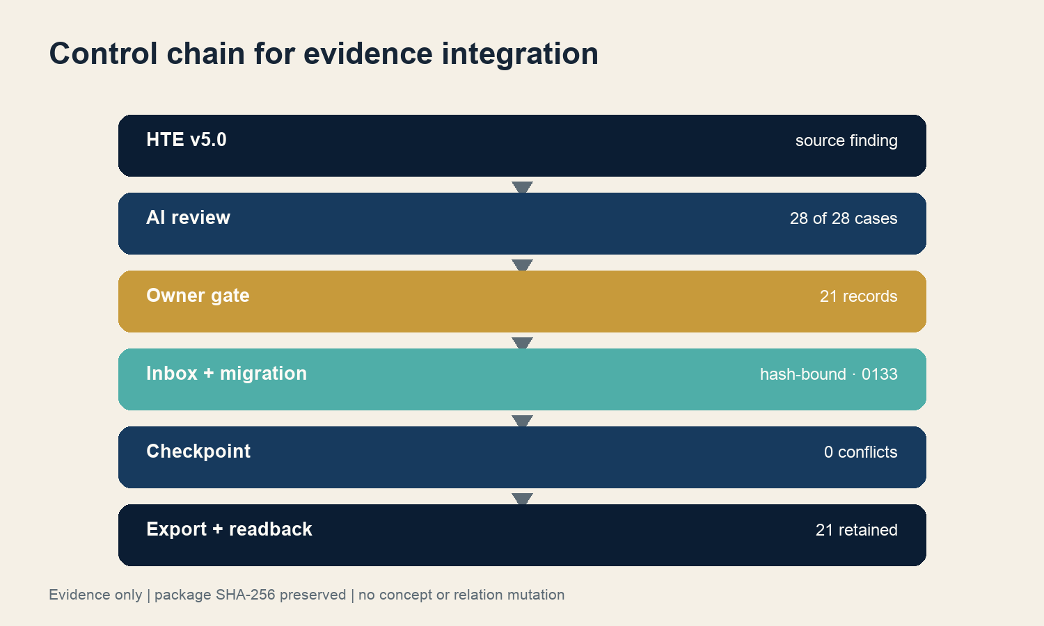
Fig. 3 Control chain for canonical integration.
Accepted package ATLAS-INBOX-HTE-PILOT-V1-EVIDENCE-0001 was transferred byte-identically with its SHA-256 unchanged. The strict Inbox run returned the expected already-imported-and-unchanged state. Dry-run and apply produced exactly 21 additions, zero duplicates, zero conflicts and no unexpected changes. Migration 0133 assigned evidence IDs 1719 through 1739. An append-only production checkpoint sealed the reconciled state while preserving the preceding WALS checkpoint.
Data layer | Before HTE | Immediately after HTE in 8.15.6 | Current 9.0.0 readback | HTE effect
Atlas version | 249 | 249 | 250 | 0 new concepts
Concepts | 1,028 | 1,028 | 1,024 | 0; later change from WordNet duplicate merge
Relations | 3,433 | 3,433 | 3,427 | 0; later change from WordNet consolidation
Evidence | 1,718 | 1,739 | 1,739 | +21
Legacy crosswalks | 18 | 18 | 18 | 0
V2 crosswalks | 106 | 106 | 872 | 0; later increase from WordNet
Typological crosswalks | 9 | 9 | 9 | 0
Active unresolved relations | 0 | 0 | 0 | 0

The current readback proves persistence, not a later expansion of the HTE package. All 21 HTE evidence records remain present even though the Atlas version, concept count, relation count and V2 crosswalk count changed in the subsequent WordNet release. Package ID and package hash remain the provenance anchors.

7 Impact on the Atlas project
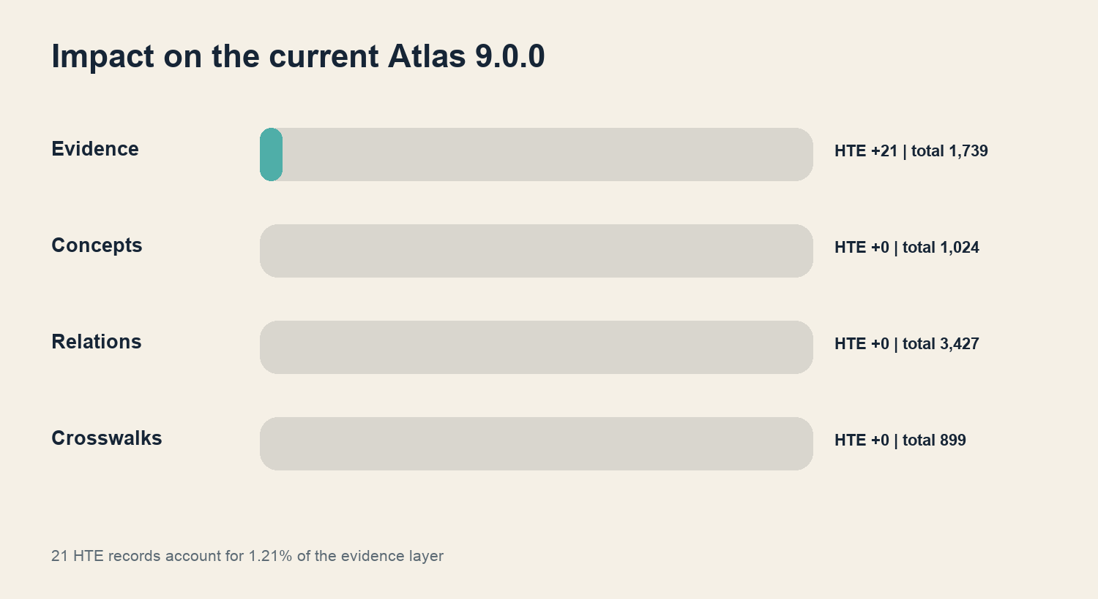
Fig. 4 Quantitative impact on Atlas 9.0.0.

7 1 Scholarly impact
HTE adds a diachronic dimension that synchronic lexical resources expose only partially. Rhetorical figures, conversational actions, genres and grammatical categories gain recorded historical anchors. At the same time, explicit scope types prevent English evidence from being misread as a cross-linguistic definition.

7 2 Data-model and editorial impact
The project gains a tested evidence-only pattern. Historical external findings can strengthen provenance without overwriting internal concept decisions or the relation graph. This pattern is particularly suitable for resource-constrained private research because every step is additive, reversible and inspectable. Later editorial reassessment can change the weight of an individual evidence record without creating a new Atlas concept.

7 3 Quality and release governance
HTE reconciliation exposed a gap that a correct handoff file alone cannot close: main may advance after a project has recorded its final checkpoint. The existing project ledger is therefore complemented by a required pull-request integration gate. The PR must be based on current github/main; a divergent merge base or an advanced stored base SHA fails with BASE_ADVANCED. Combined with the branch-protection requirement that branches be up to date, this covers the interval after the final local project checkpoint and before actual integration.
Project risk | Existing control | Added effect
Source changes category or date | HTE version and URL in evidence | reproducible review against v5.0
String equality is treated as identity | multi-stage scope review | direct, broader, narrower, context and negative remain separate
AI recommendation is mistaken for acceptance | owner gate | approval remains a human project decision
Accepted package drifts | package SHA and Inbox check | byte-identical provenance
Import changes other data layers | dry-run, migration, tests, readback | HTE remains limited to 21 evidence additions
main advances after handoff | PR base gate plus up-to-date rule | a stale green check cannot be integrated

7 4 Quantitative impact
The 21 HTE records account for 1.21 percent of the current 1,739 evidence records. The volume is modest but structurally important: it establishes a historical, version-bound evidence type and proves its complete lifecycle from source research to persistence after a later major release. Its impact is therefore more qualitative than volumetric.

8 Reproducibility and quality assurance
Artifact | Function | Integrity feature
pilot-selection.jsonl | selection of 28 cases | bounded, inspectable scope
pilot-crosswalk.jsonl | source-close HTE findings | version, category path, URL and rationale
ai-expert-review-v1.jsonl | multi-stage challenge review | recommendation separated from approval
Accepted package | 21 atomic evidence operations | package ID and SHA-256 unchanged
Migration 0133 | canonical apply | IDs 1719 through 1739, transactional
Production checkpoint | append-only seal | predecessor superseded without overwrite
Canonical export | machine-readable final state | 21 HTE records among 1,739 evidence records
Readback | independent corpus verification | 0 active unresolved relations

Technical completion includes format and schema checks, package and record hashes, the complete test suite, build, release check, final canonical export and full readback. Any substantive or data deviation is a stop condition. A runtime-only problem may be addressed solely through a documented content-neutral shim.

9 Limitations and future work
• The pilot is purposive and not representative of all 1,024 current Atlas concepts.
• HTE describes the history of English and does not establish cross-linguistic universals.
• Recorded dates depend on source survival and are not absolute origins.
• HTE neighborhood is not strict synonymy and must not be translated automatically into Atlas relations.
• The terms of use do not permit unrestricted replication of large HTE datasets; this closeout therefore publishes no raw-data copy.
• AI review is proportionate quality assurance for a private project, not a relabeling of human peer review.
• A future HTE release requires renewed source review; version 5.0 remains part of every accepted evidence claim.

10 Conclusion
The HTF research track is complete at both scholarly and technical levels. Twenty-one scope-typed HTE evidence links were derived from 28 methodologically selected cases, while four contexts and three non-matches remain explicitly documented. The accepted import was strictly additive. Its unchanged package hash, evidence IDs 1719 through 1739 and complete persistence in the Atlas 9.0.0 readback make the path from research to canonical evidence reproducible.
The project-wide gain is twofold. The Atlas now has a historical evidence layer without surrendering its ontology to HTE; and release governance gains an integration-time guard that protects the handoff state against a subsequently advancing main. HTE is therefore both a completed source contribution and a reference procedure for future external research tracks.

Sources and artifacts

Primary sources
• Historical Thesaurus of English: Versions and changes, version 5.0, accessed 11 September 2026.
• Historical Thesaurus of English: How to cite, accessed 11 September 2026.
• Historical Thesaurus of English: Classification, accessed 11 September 2026.
• Historical Thesaurus of English: Guide, accessed 11 September 2026.
• Historical Thesaurus of English: Sources, accessed 11 September 2026.
• Historical Thesaurus of English: Terms and conditions, accessed 11 September 2026.
• University of Glasgow Research Data Repository: Historical Thesaurus of English record, DOI 10.5525/gla.researchdata.2163.

Project artifacts
• pilot-selection.jsonl - 28 selected Atlas concepts.
• pilot-crosswalk.jsonl - source findings and initial mapping decisions.
• ai-expert-review-v1.jsonl - multi-stage AI review and revised decisions.
• ATLAS-INBOX-HTE-PILOT-V1-EVIDENCE-0001 - accepted evidence-only import package.
• Migration 0133 and the append-only HTE production checkpoint.
• Canonical export and Atlas 9.0.0 readback with 21 persistent HTE evidence records.

Data products and citation
Machine-readable exports, packages and import logs remain authoritative for verification. The editorial DOCX and PDF editions explain method and result; they are neither import sources nor approval documents for new data.
RECOMMENDED CITATION:
Reich, Michael (2026): Historical Thesaurus of English and the Atlas of Language. Final report of the HTF research track and canonical evidence integration. Research Report 05, version 1.2. Atlas of Language / Atelier der Resonanzen.

Transparency note
The visual design belongs to the Atlas research perspective. Diagrams visualize only the selection, review and integration data documented in this report; they do not replace external data analysis. Historical source, Atlas interpretation and canonical acceptance remain separate levels of claim.
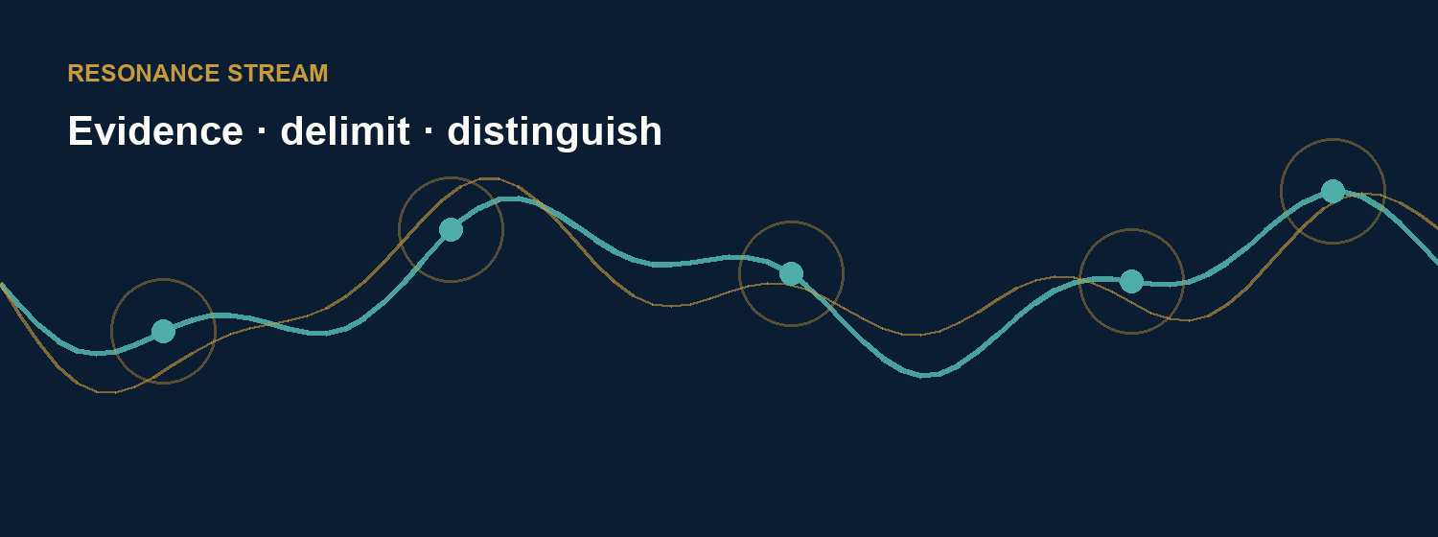
Closing image Historical evidence responds; the Atlas retains its own voice.

