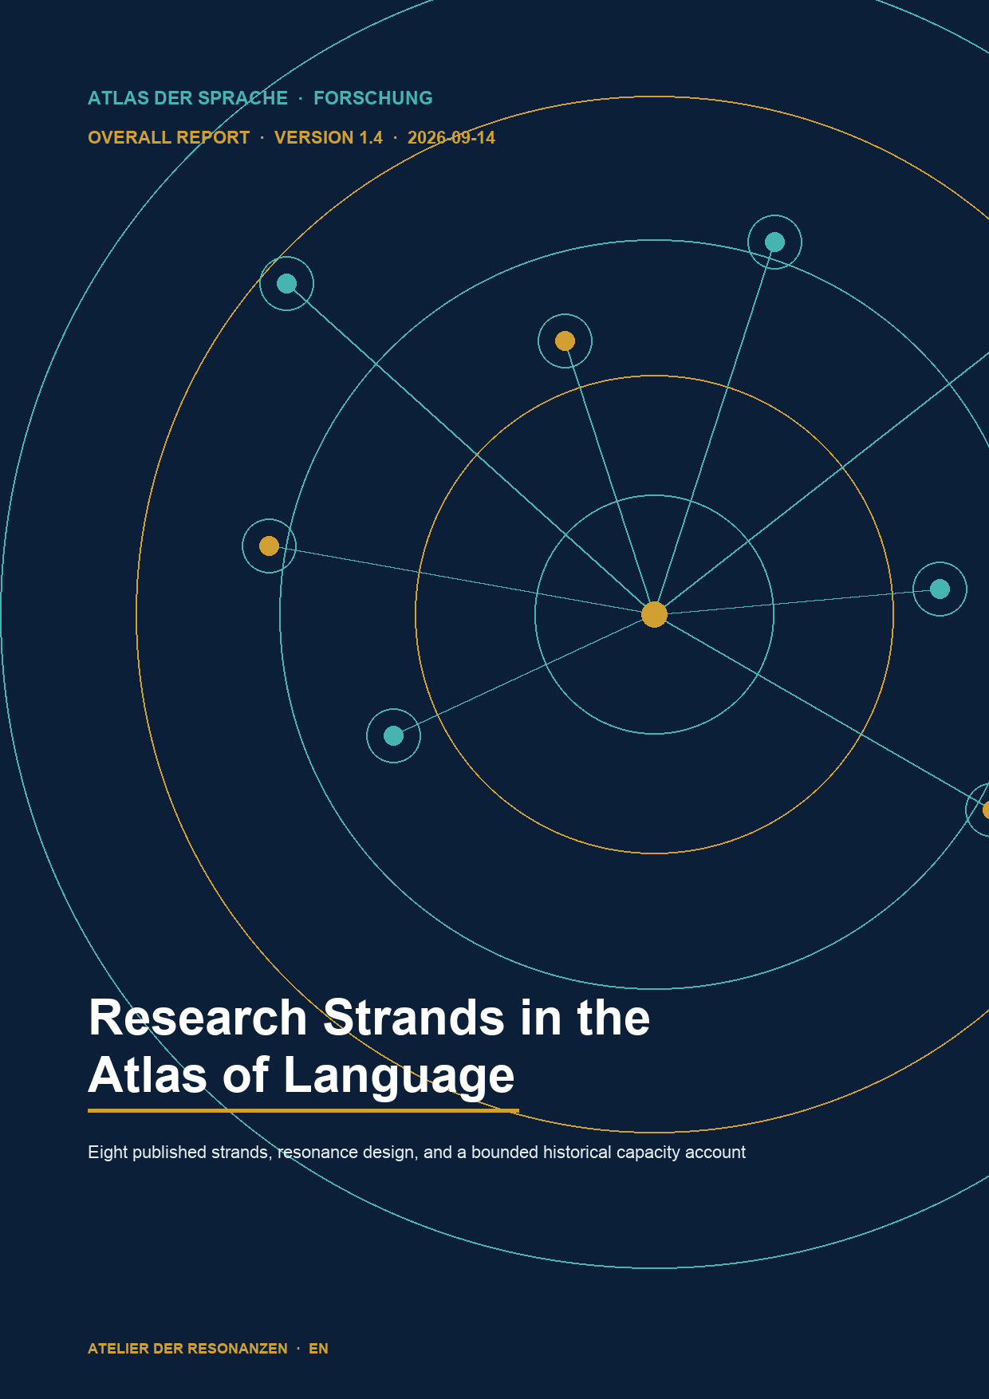

Overall status and core conclusion
As of 14 September 2026, eight research strands have published reports and their own DOI datasets. The Atlas research page displays nine cards; the ninth strand, on Chinese rhetoric, remains under source review and is not counted as completed.
The portfolio is scientifically complementary. Lexical identifiers, colexifications, frames, typological features, historical semantic spaces, translation limits, and metaphorical relations are documented side by side without equating the external systems with the Atlas.
Metric | Value | Status boundary
Published research strands | 8 | Report and DOI evidenced
Research cards in the Atlas | 9 | One card remains source-review
Canonically effective strands | 5 | CLICS, WordNet, FrameNet, WALS, HTE
Research-only strands | 3 | Cassin, ILIESI, Mapping Metaphor
Historically measured capacity streams | 7 | No invented value for ILIESI

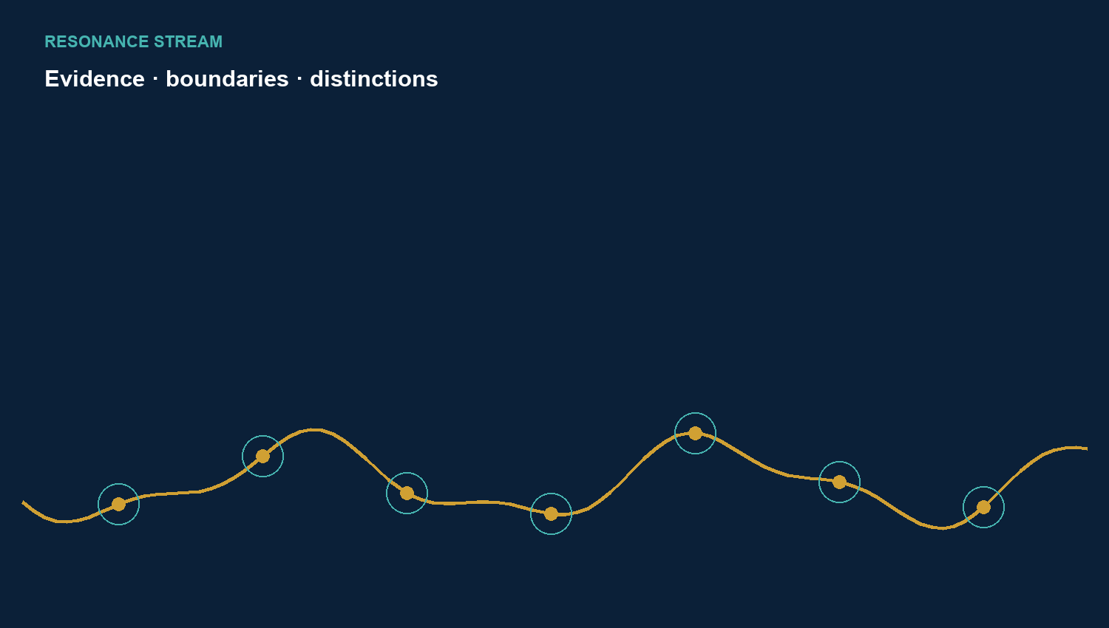

Broad semantic access
WordNet. Screening all 1,028 original Atlas concepts produced 342 Sense-Key crosswalks for 301 concepts after audit and editorial gating. Of 196 single-sense hits, 155 were confirmed and 41 rejected. NO_MATCH remains a valid result rather than an Atlas error.
CLICS. The complete review decided 855 reasoning paths: 726 were approved and 129 withheld. Explicit network gaps remain visible. A reasoning path is neither concept identity nor a depth dossier; network proximity is not reported as equivalence.
Strand | Result unit | DOI
WordNet | 342 links / 301 concepts | 10.5281/zenodo.22713535
CLICS | 726 approved / 129 withheld | 10.5281/zenodo.22691224

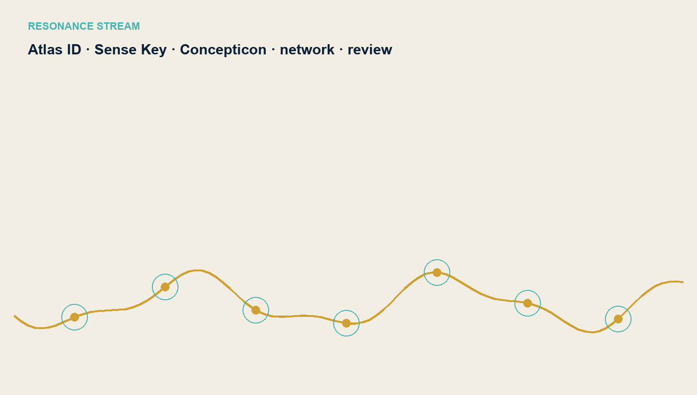

Scenes and language structures
FrameNet. The full review confirms 532 typed crosswalks covering 465 concepts. Frames, Frame Elements, and Lexical Units remain separate evidence layers; 563 concepts have no positive crosswalk. Frame proximity or identical wording is insufficient.
WALS. The typological pilot documents 36 evidence-only records for 18 concepts and nine typological crosswalks. Feature, value, language, and Atlas interpretation remain separate. A value from one language does not establish universality.
Strand | Result unit | DOI
FrameNet | 532 links / 465 concepts | 10.5281/zenodo.22713158
WALS | 36 evidence records / 9 crosswalks | 10.5281/zenodo.22713208

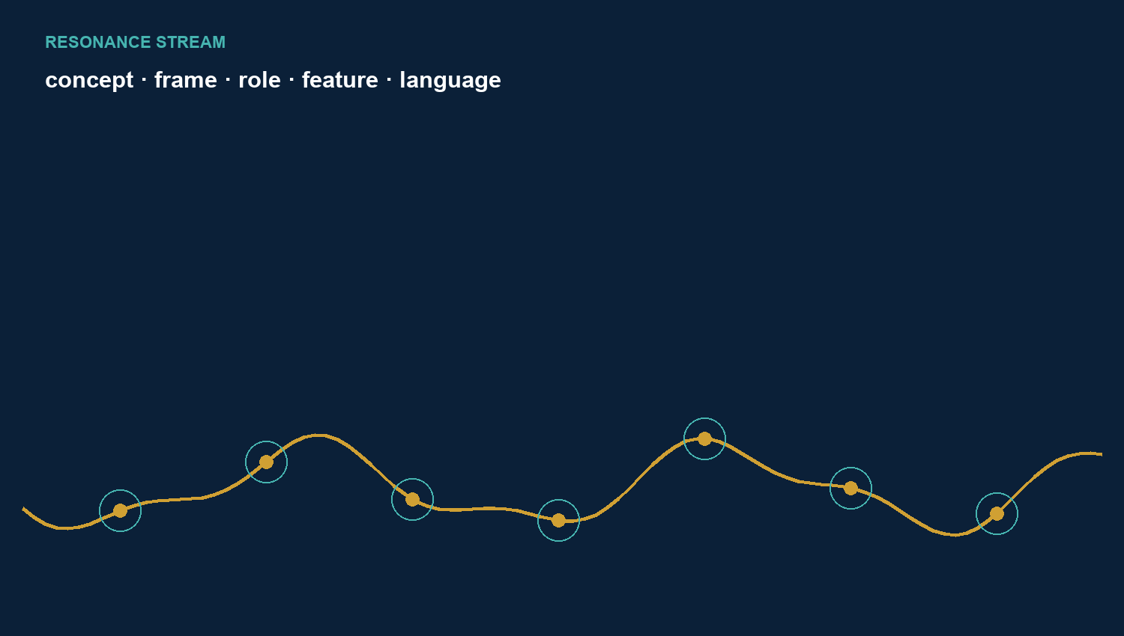

History and metaphorical pathways
Historical Thesaurus of English. The bounded pilot covering 28 Atlas concepts produced 21 owner-accepted, scope-typed HTE evidence records. Four contextual and three negative findings remain separate. The public Atlas dataset contains no HTE raw data or hierarchy exports.
Mapping Metaphor. Ten prioritised Atlas concepts were examined in depth: eight cases are supported within explicit scope limits and two are partial. Counterevidence, null findings, and 30 AI-internal test passages remain documented. AI dry runs are not human reliability; no media validation or canonical integration occurred.
Strand | Result unit | DOI
HTE | 21 evidence / 4 context / 3 negative | 10.5281/zenodo.22752606
Mapping Metaphor | 8 supported / 2 partial | 10.5281/zenodo.22735837

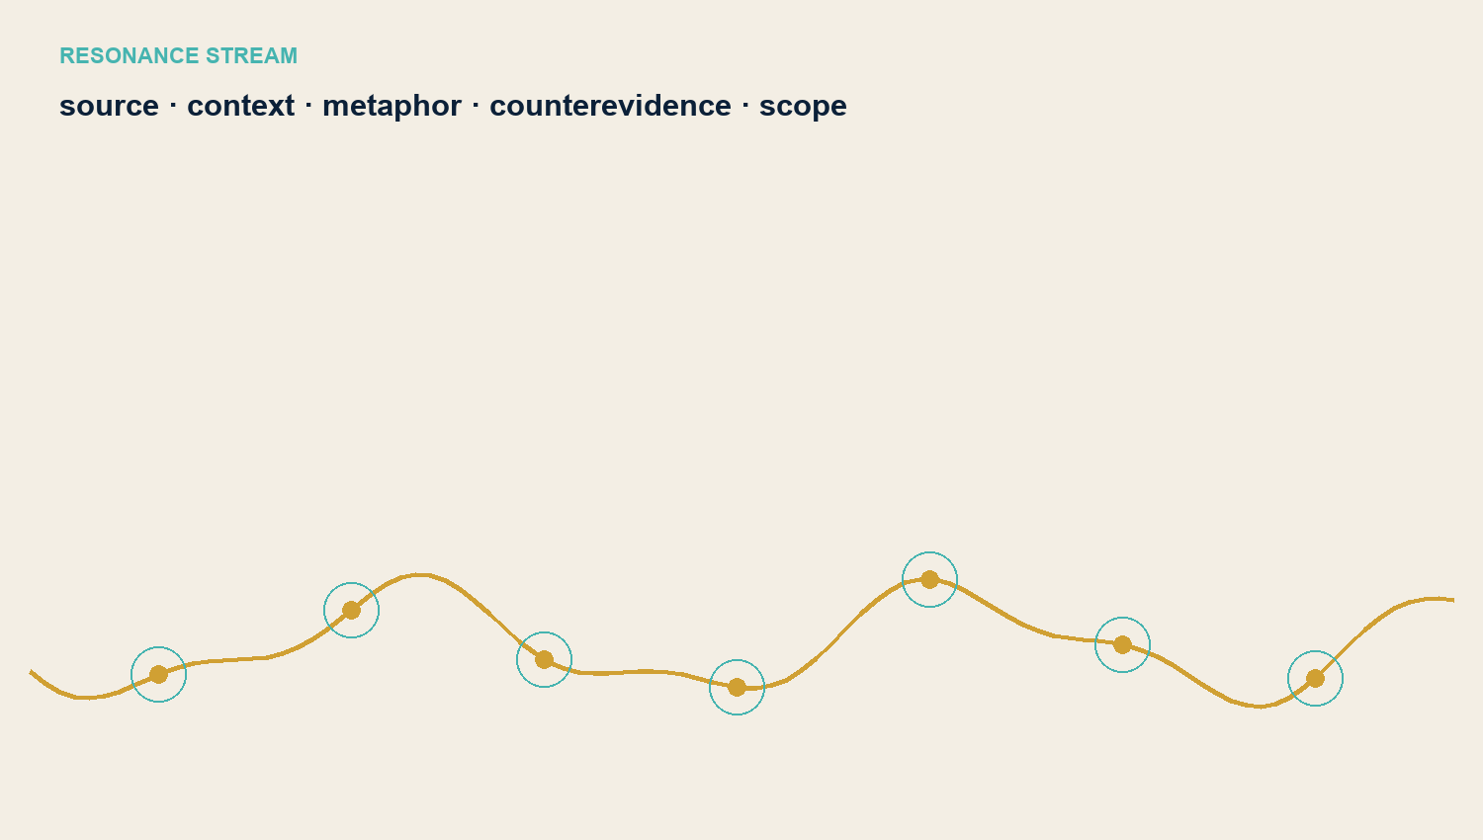

Translation limits and historical contextual reading
Cassin. Twelve concept cases and 24 published translation paths were examined through primary texts, lexicography, same-passage comparison, and countermodels. Adjudication yielded A=4, B=13, C=5, and X=2. The Ubuntu case remains open; there is no canonical Atlas integration.
ILIESI. The extended pilot examined eight Atlas concepts in seven cases using 15 evidence records covering three authors. Translations of the same passage do not count as independent findings. There was no human review or canonical integration; further depth work remains deferred.
Strand | Result unit | DOI
Cassin | 12 cases / 24 paths / 2 X | 10.5281/zenodo.22736783
ILIESI | 8 concepts / 7 cases / 15 records | 10.5281/zenodo.22749535

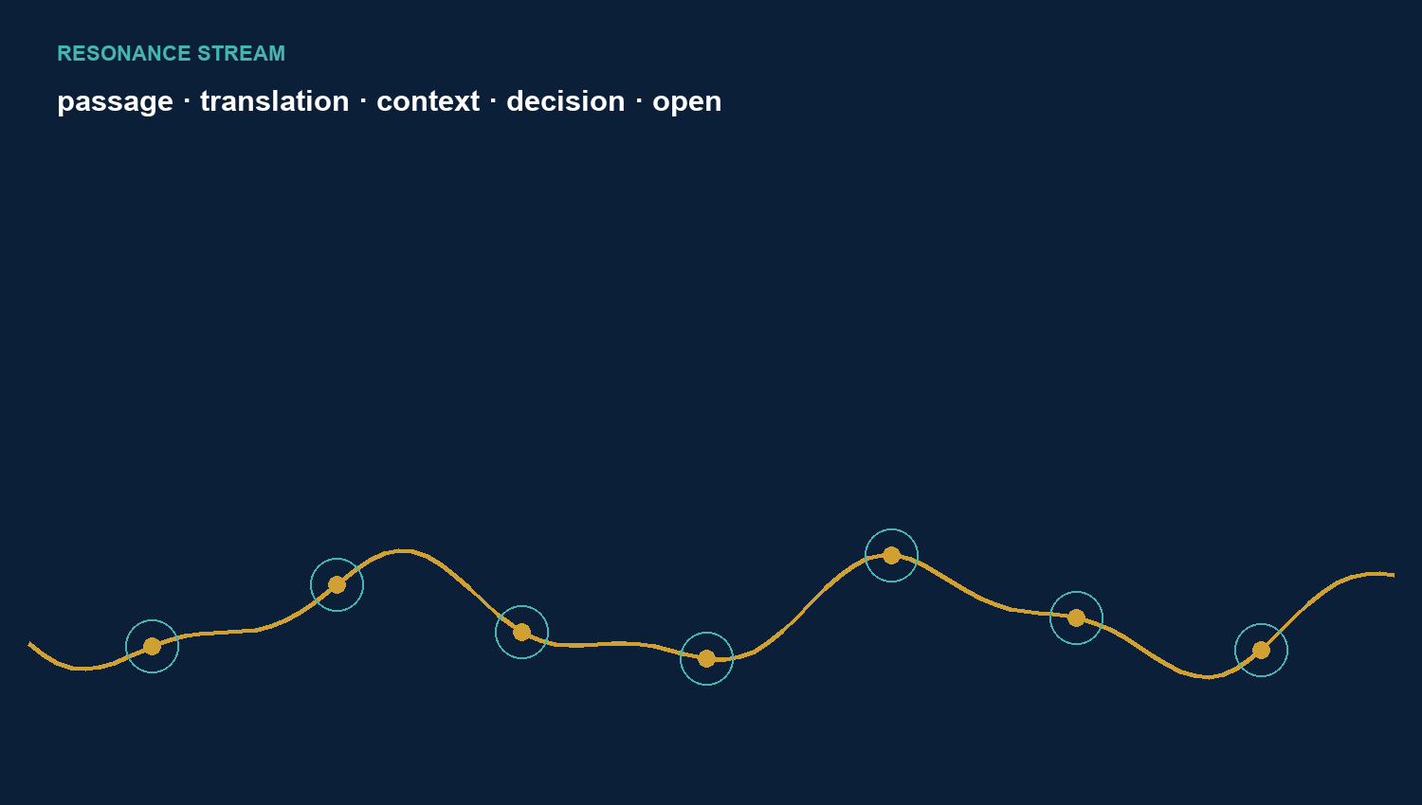

Reports datasets and citation routes
Each published strand has a report and a concrete version DOI. DOCX files remain editorial companion products; the citable record is the respective Zenodo dataset. The DOI of an external source system remains distinct from the Atlas publication.
Citations identify the concrete Atlas version with author, year, title, version, Zenodo, and DOI. External data sources are also cited with their own versions and rights bases. Chinese rhetoric remains source-review and has no research report or DOI dataset yet.
Strand | Report | Atlas effect | Version DOI
CLICS | DE / EN PDF | Denkwege / reasoning paths | 10.5281/zenodo.22691224
WordNet | DE / EN PDF | Crosswalks | 10.5281/zenodo.22713535
FrameNet | DE / EN PDF | Crosswalks | 10.5281/zenodo.22713158
WALS | DE / EN PDF | Evidenz / evidence | 10.5281/zenodo.22713208
HTE | DE / EN PDF + DOCX | Evidenzen 1719-1739 | 10.5281/zenodo.22752606
Cassin | DE / EN PDF + DOCX | research-only | 10.5281/zenodo.22736783
ILIESI | DE / EN PDF + DOCX | research-only | 10.5281/zenodo.22749535
Mapping Metaphor | DE / EN PDF + DOCX | research-only | 10.5281/zenodo.22735837

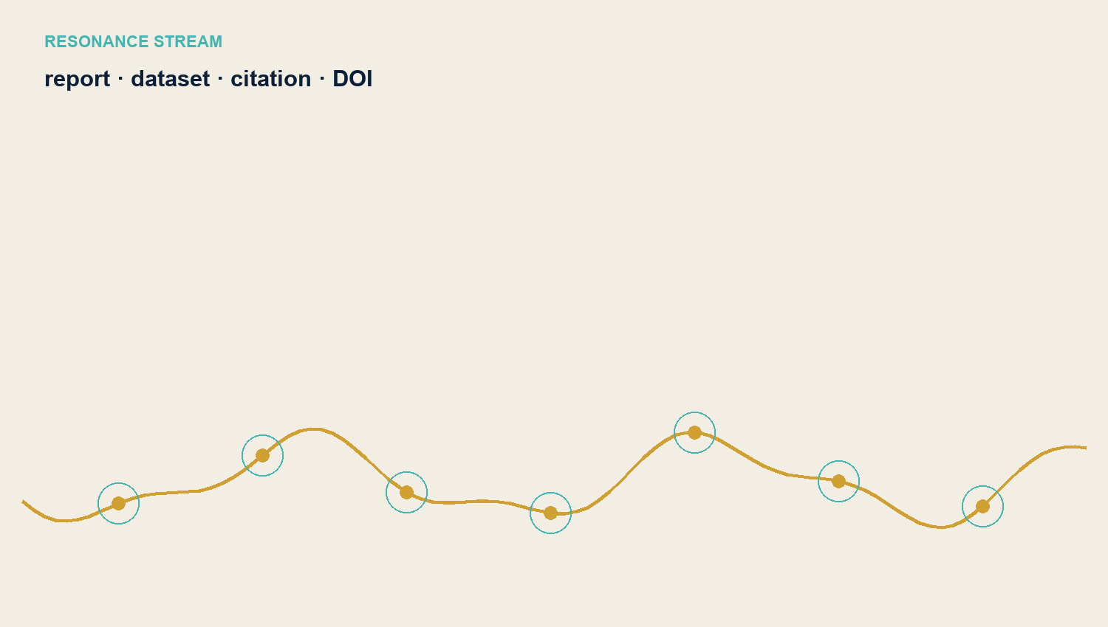

Observed capacity with an explicit boundary
The capacity retrospective preserves the frozen values from overall report 1.2. It is not a new consumption analysis. Seven project streams total 1,532.58 million raw tokens; shared work adds 58.53 million; the total is 1,591.11 million. No consumption value was retrospectively invented for ILIESI.
Token quantities describe observed model capacity within bounded work windows. They do not measure scientific quality, human labour time, GPU time, energy use, or monetary cost. Missing values remain missing rather than being reported as zero.
Strand | Million raw tokens
WordNet | 173.81
CLICS | 194.25
FrameNet | 301.65
WALS | 136.62
HTE | 134.62
Mapping Metaphor | 208.28
Cassin | 383.35
Shared work | 58.53
ILIESI | not measured

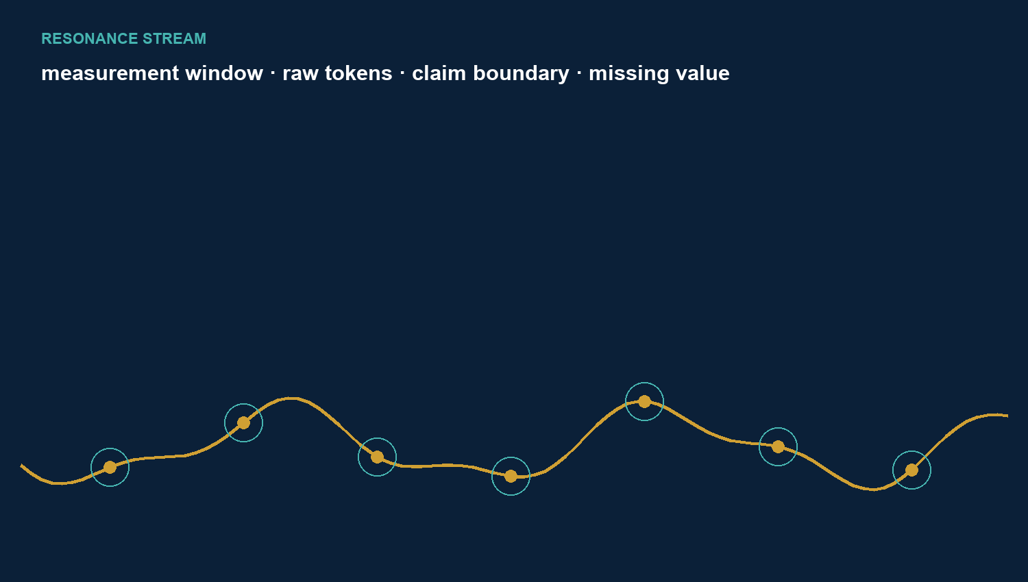

Use in relation to effort
The projects use different result units. A smaller capacity value per unit does not mean greater truth or scientific worth. Meaningful comparison starts with the research function of each strand.
WordNet, CLICS, and FrameNet create broad connection surfaces. WALS and HTE bind selected typological and historical source claims to the Atlas. Cassin, ILIESI, and Mapping Metaphor test non-equivalence, contextual dependence, countermodels, and open decisions. Research-only is a substantive status boundary, not a failure.
Target profile | Strands | Typical yield
Breadth and connection | WordNet, CLICS, FrameNet | Concepts, paths, scenes, and roles
Targeted evidence | WALS, HTE | Typological and historical source binding
Depth and method testing | Cassin, ILIESI, Mapping Metaphor | Case dossiers, countermodels, scope limits

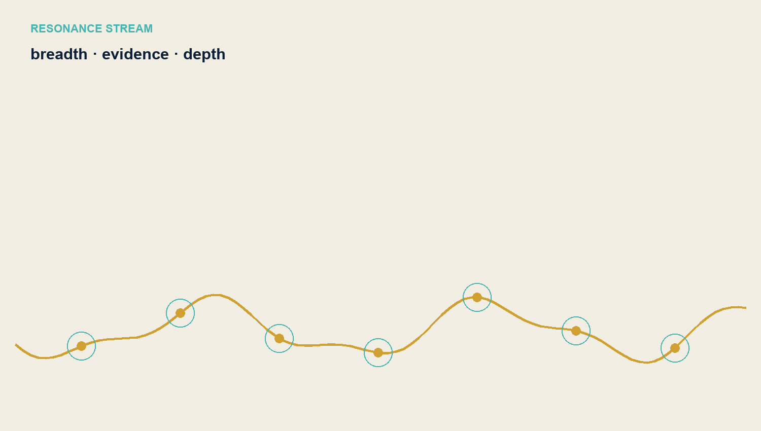

Failed attempts detours and corrections
Detours are retained because they show which boundaries must be clarified before future series production. A failed attempt is not recast as a successful empirical study or a mere layout detail.
The first Mapping Metaphor report failed to separate the language editions and did not implement the resonance design. The human and media branch required real coders, raters, audio, and video that were unavailable. The visually unsuccessful overall report V1.3 described resonance methodologically but did not implement it graphically. V1.4 corrects these failures openly.
Case | Correction
First Mapping report | Separate German and English resonance editions
Human and media branch | Honest research-only closeout; AI-internal status explicit
HTE typesetting and design | Approve specimen pages before full layout
Cassin empty space | Density check and final image before series production
Overall report V1.3 | Complete rebuild as resonance edition V1.4

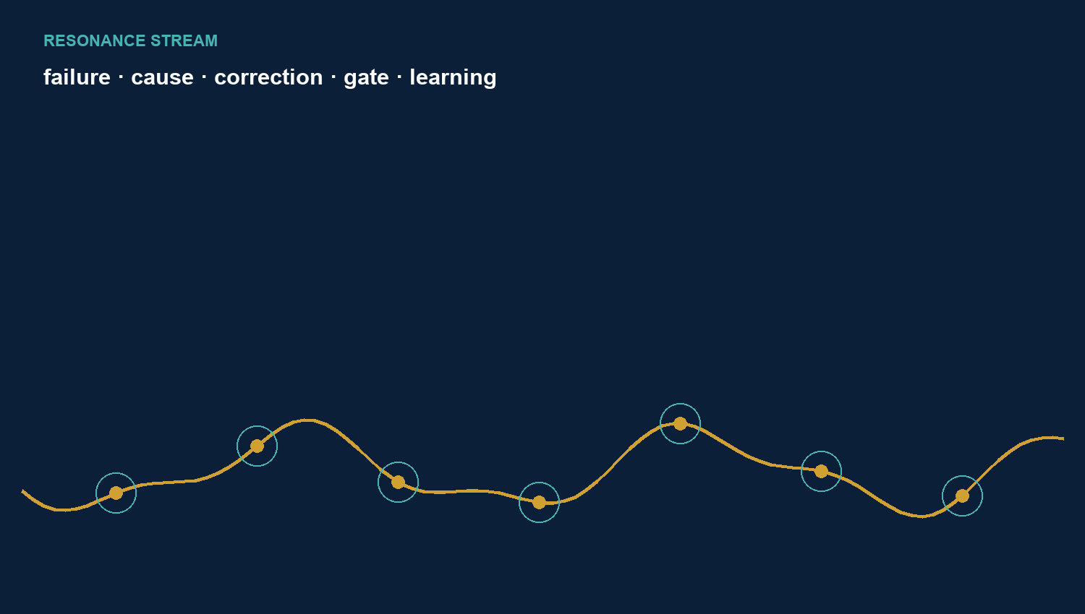

Procedure and resonance design
Research, integration, publication, and layout have separate gates. A successful research closeout does not automatically authorise integration or publication. A DOI publication does not prove canonical Atlas impact.
Resonance means neither identity nor harmony. Dark navy marks the Atlas as a frame of reference; gold marks evidenced decisions; turquoise marks relations and distinct domains; cream marks inspectable evidence fields. Evidencing, bounding, distinguishing, and connecting are the methodological equivalents.
Visible free space is not automatically treated as calm. Every page uses available space for text, tables, diagrams, or resonance imagery. Deliberate emptiness would require separate approval.
Gate | Minimum evidence
Research | Source, primary finding, countercheck, uncertainty
Integration | Separate data model, controlled apply, readback
Publication | Report, dataset, rights, DOI, deployment, live readback
Layout | Resonance template, specimen pages, rendering, visual check

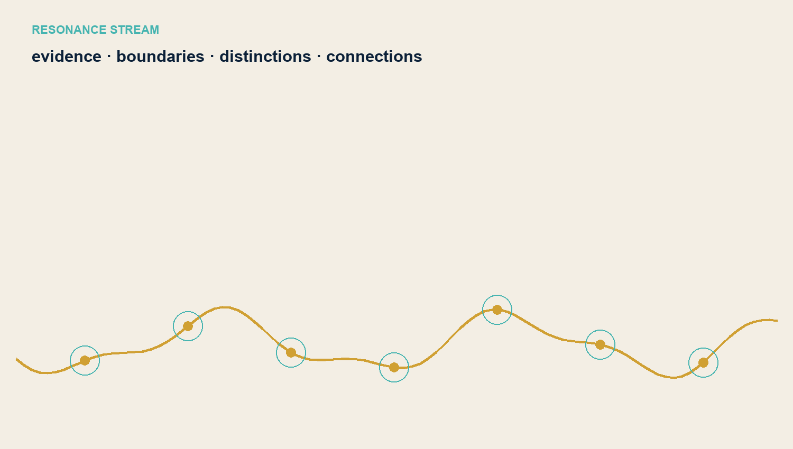

Data products citation and sources
The datasets publish project-side decisions, Atlas IDs, typings, source links, and audit evidence. External databases, protected translations, and unreleased full texts are not republished as open data owned by the project.
Central citation: Reich, Michael (2026): Research Strands in the Atlas of Language. Overall Research Report in Resonance Design. Version 1.4. Atelier der Resonanzen / Atlas der Sprache, 14 September 2026.
The source base consists of the eight published research reports and their Zenodo datasets, the Atlas research library as of 14 September 2026, the historical capacity account in overall report 1.2, and approved Atlas research standard v1.0. External primary sources and rights notices remain in the individual reports.
Strand | Published Atlas layer | Boundary
CLICS | Reasoning paths and status | External IDs separate
WordNet | Sense-Key crosswalks | WordNet rights external
FrameNet | Typed crosswalks | Frames and LUs external
WALS | Evidence and crosswalks | No universalisation
HTE | Project decisions | No HTE raw data
Cassin | Case dossiers | No full translation texts
ILIESI | Evidence register | Edition caveats
Mapping Metaphor | Research-only evidence | No human validation

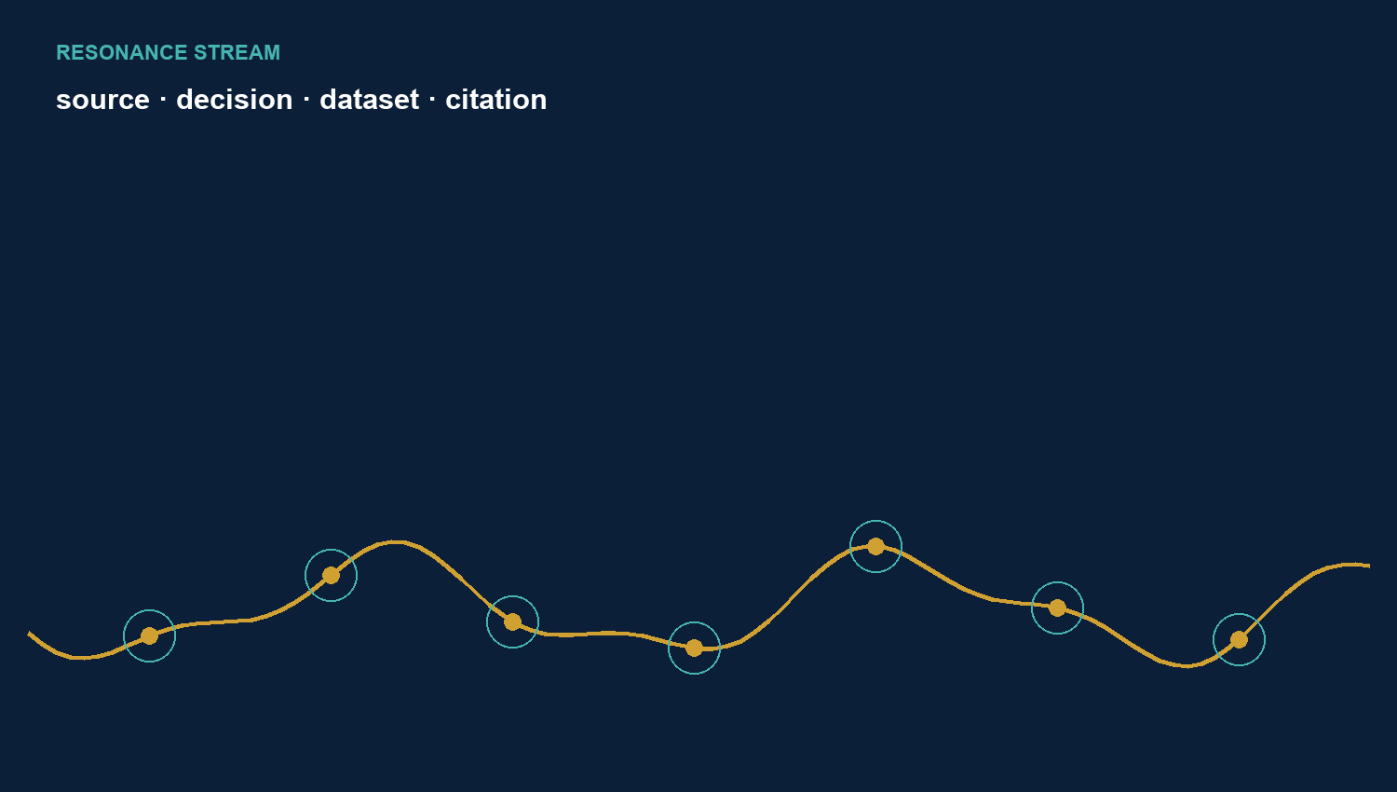

Eight strands and a shared field of knowledge
The Atlas of Language now has eight published research strands with their own reports and DOI datasets. Five strands have canonical effects through reasoning paths, crosswalks, or evidence; three remain deliberately research-only. That distinction is part of the result.
WordNet, CLICS, FrameNet, WALS, HTE, Cassin, ILIESI, and Mapping Metaphor answer different questions. The resonance design connects their findings without unifying their categories, rights, or validity boundaries.
The first Mapping closeout, the unavailable human and media branch, and the visually unsuccessful overall report V1.3 remain acknowledged. V1.4 replaces that edition visually without denying its existence or the computational work it consumed.
Inventory | Closing statement
8 published strands | Reports and version DOIs documented
5 canonically effective strands | Atlas effect evidenced separately
3 research-only strands | No claimed canonical effect
1 further strand under source review | Chinese rhetoric outside the completed inventory
7 historical capacity streams | No invented consumption value for ILIESI

