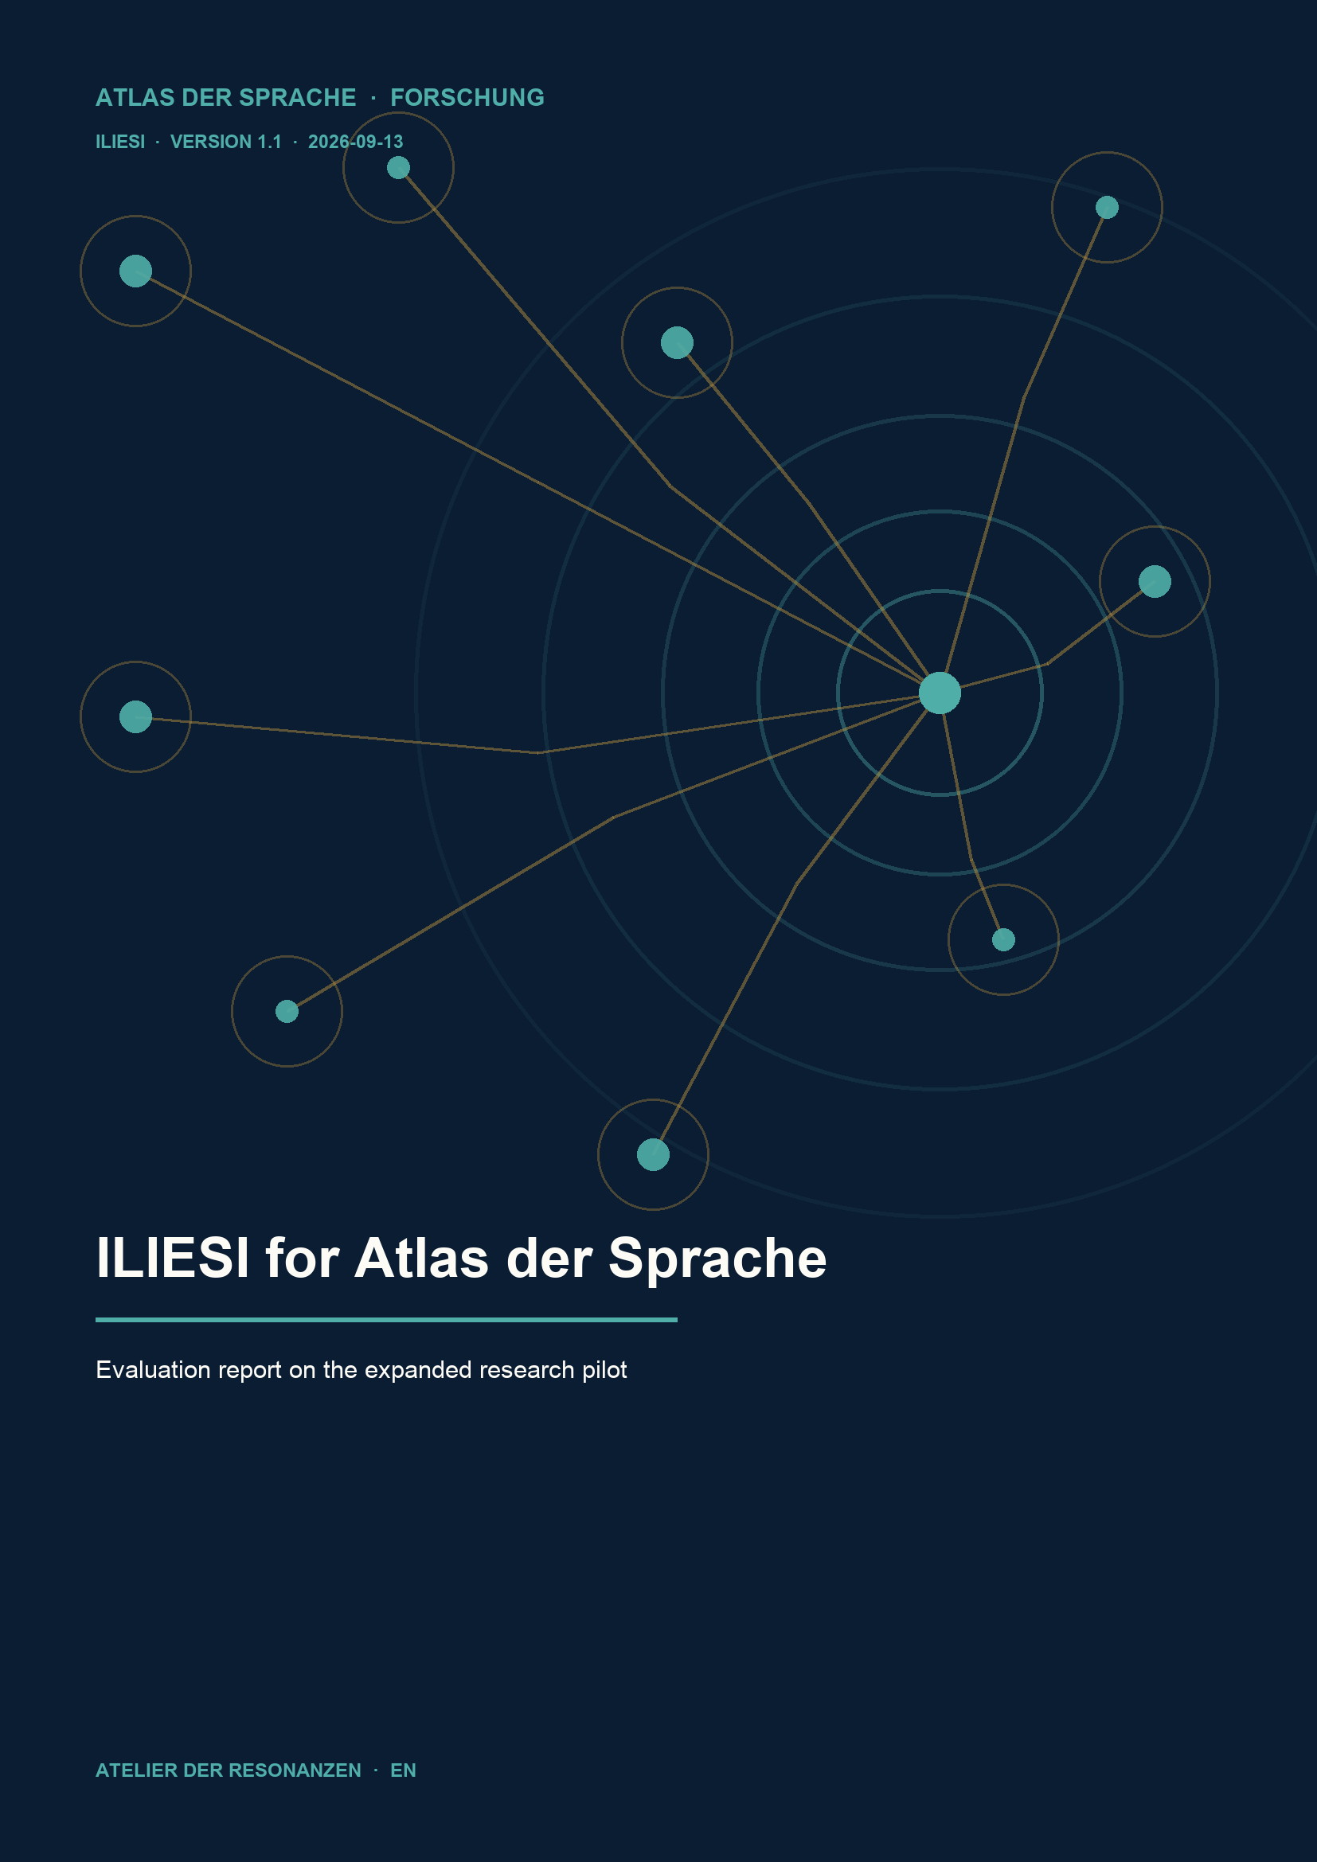

Decision and remit
ILIESI should remain on the research list as a supplementary source for focused historical interpretation. The strongest concrete additions concern perspective, analogy and metaphor. Affect and attention benefit more narrowly; equivalence gains new material for an existing method. Medium priority is recommended for later work. The sample does not justify comprehensive processing.
The guiding question is whether ILIESI adds demonstrable value to the Atlas beyond its existing content. At the project owner’s request, an initial feasibility probe using Descartes was followed by a broader decision review. This report brings both stages together. It documents a completed pilot evaluation, not independent scholarly peer review.

Scope and counting rules
The review covers eight existing Atlas concepts in seven application cases, three authors and two resources subjected to textual reading. Nine records were added to the first probe’s six evidence records. The 15 records include translations of the same passages; they are neither 15 independent findings nor 15 approved Atlas mappings. Two further resources were inspected at catalogue level only.
Textual reading: Lessico delle passioni in età moderna, using Descartes and Cureau de la Chambre [S01-S05; N-S01-N-S02]; Le prime traduzioni della Monadologie, using the French text and German and Latin translations [N-S03-N-S06]. Catalogue probes: the philosophical text database and the Chauvin lexicon [N-S07-N-S08].

Comparison and verification
Each application case distinguishes the existing Atlas profile, the precise source finding, the potential addition and any counterargument. The basis was the locally manifest-verified Atlas 250 export of 11 September 2026, 19:19:56.671 UTC, containing 1,024 concepts. The eight relevant profiles, including their source and translation fields, were read alongside the Mapping Metaphor pilot report and the Cassin C6 comparison matrix [I01-I03].
Short quotations and locators were technically checked against the saved retrievals. Nine relevant Leibniz PDF pages were also inspected visually. These PDFs are digital transcriptions. Collation with historical print facsimiles and a current readback of Atlas production are outside the verified scope.
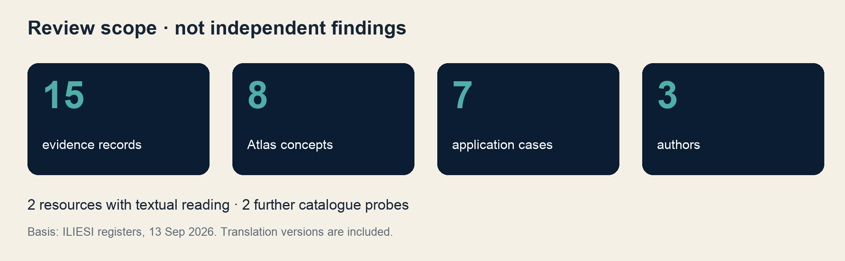

Results of the seven application tests
Case and Atlas concept | Evidence and assessment
U01 Attention  AT-CORE-238-011 | ILP-E01-E03  Addition to HTE and WordNet: Descartes connects surprise with attention. Limited incremental value.
U02 Affect  AT-CORE-238-010 | N02-N03  Cureau distinguishes movement form and motive. Focused historical interpretation is useful.
U03 Analogy and metaphor  AT-CORE-238-029; AT-RHE-0002 | N01; N03  Explicit model transfer and a countercheck. Particularly useful set of examples.
U04 Perspective  AT-W3-0411 | N07-N08  Leibniz’s city comparison provides precise historical explanatory evidence. Strong concrete addition.
U05 Equivalence  AT-W3-0296 | N04-N06  Trilingual material for the existing Cassin method. No new methodological framework needed.
U06 False friend  AT-W3-0299 | N04-N06  Unfamiliar historical wording is insufficient. No positive match.
U07 Emergence  AT-SYS-0001 | N09  The mill argument does not support the Atlas definition. No positive match.

What the comparison establishes
The two strongest cases provide precise historical textual examples. They do not establish identity between a historical term and an Atlas concept. Equivalence has a different kind of value: Cassin already developed the contextual comparison procedure; ILIESI adds dated versions to which it can be applied [I03].
In the Mapping Metaphor pilot, perspective was classified as thematic or network proximity; metaphor had a negative or null finding at the mapping level examined there. The ILIESI passages add a different evidence type and do not overturn those results [I02].
The eight fully read profiles do not explicitly name Descartes, Cureau, Leibniz, Monadologie or ILIESI. This identifies a gap in the inspected profiles. It does not prove that these authors are absent from the underlying reference works or from every other part of the project.

Three concrete contributions

Perspective in Leibniz
The comparison of a city appearing differently from different sides explains differing perspectives on one world. The French version contains it in §57, PDF page 19, edition marker 105; Köhler’s German translation of 1720 places it in §58, PDF pages 28-29, edition markers 27-28 [N07-N08; N-S03-N-S04]. The different numbering was verified. Matching paragraph numbers cannot replace textual alignment.
For the Atlas this is a historical explanatory example with a precise locator. The comparison belongs to Leibniz’s particular metaphysics and does not establish that arbitrary opinions are equally valid. A later source box could explain this scope in a few sentences.

Analogy and metaphor in Cureau
In the preface to Le Système de l’Ame, Cureau explains his adoption of the astronomical concept of a system to examine the faculties of the soul. This is an explicitly stated transfer of an ordering pattern. In Book VI, Chapter I, Article V, however, he treats movements of the soul as actual local movements [N01; N03; N-S01].
The combination provides an example and a countercheck: the argument establishes a model transfer, while spatial wording alone does not make a statement metaphorical. The adjacent affect case adds that different motives may accompany the same form of movement [N02]. The exact print year and underlying printed edition of the Cureau transcription have not been verified here.

Historical translation choices
Section 14 of the Monadologie distinguishes perception from apperception or conscience. Köhler’s version uses Empfindung oder Perception and Apperception or Bewust seyn. The Latin version has perceptionem and apperceptione or conscientia [N04-N06]. These forms illustrate a contextual translation choice, not a general network of synonyms.
According to ILIESI, the French text follows Robinet 1954, the German version follows Köhler’s first edition of 1720, and the Latin version follows the Actorum Eruditorum Supplementa of 1721, which names no translator. A. Russo prepared the digital texts; the associated book by Lamarra, Palaia and Pimpinella appeared in 2001. That book was not read in full for this pilot [N-S06].
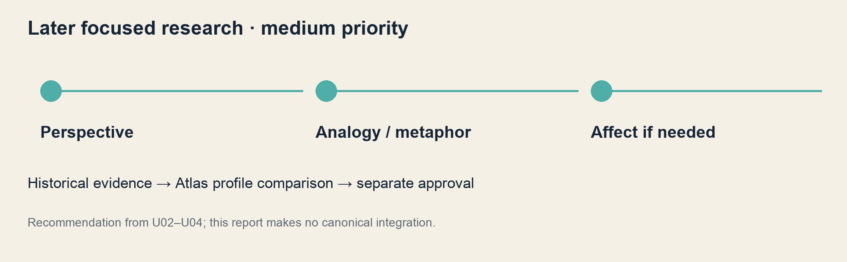

Index of the 15 evidence records
Identifiers are preserved from the two original registers. PDF pages are counted from 1; other page references denote portal or edition markers. The table paraphrases the findings. Wording, language version, retrieval evidence and verification status are recorded in the accompanying registers.
Record / source | Locator | Narrow finding
ILP-E01 / S02 | II, Art. 53; AT 373 | Novelty before judging benefit
ILP-E02 / S02 | II, Art. 70; AT 380-381 | Surprise and attention
ILP-E03 / S03 | II, Art. 70; p33-34 | Admiratio and consideration
ILP-E04 / S02 | II, Art. 86; AT 392-393 | Future orientation of desire
ILP-E05 / S03 | II, Art. 86; p40-41 | Cupiditas as a translation form
ILP-E06 / S02 | II, Art. 87; AT 393-394 | Seeking and avoiding as movement
N01 / N-S01 | Préface | Astronomical ordering pattern
N02 / N-S01 | VI, I; p354 | Different motives
N03 / N-S01 | VI, I, Art. V; p359-361 | Actual local movement
N04 / N-S03 | §14; PDF 5 | Perception and conscience
N05 / N-S04 | §14; PDF 8-9 | Empfindung oder Perception
N06 / N-S05 | §14; PDF 2-3 | Latin distinction
N07 / N-S03 | §57; PDF 19 | City comparison in French
N08 / N-S04 | §58; PDF 28-29 | City comparison in German
N09 / N-S03 | §17; PDF 6 | Mill argument as a countercheck

Dependence between records
ILP-E02/E03 and ILP-E04/E05 are translation pairs. N04-N06 form a trilingual group; N07/N08 are two versions of the city comparison. Translations extend the comparison but do not increase the number of independent authors. The six Descartes records cover four article positions.

Sources and references
All web sources below were consulted on 13 September 2026. Identifiers refer to the original registers. Historical editions and digital provision are distinguished; missing edition details are not supplied by inference. Source links are clickable.
[S01] CNR-ILIESI. Lessico delle passioni in età moderna. Scientific direction: Pina Totaro. Resource description. ILIESI
[S02] Descartes, René. Les Passions de l’Ame. Work: 1649; ILIESI digital transcription. II, articles 53, 70, 86, 87. Exact underlying edition unresolved. ILIESI
[S03] Descartes, René. Passiones Animae. Latin translation; ILIESI transcription. II, articles 70, 86. Translator according to S05: Henri Desmarets; print year unresolved. ILIESI
[S04] CNR-ILIESI. Introduction to Les passions de l’ame. Editorial description of the French work. ILIESI
[S05] CNR-ILIESI. Introduction to the Latin translation. Title variant Animi versus Animae on the text page. ILIESI
[N-S01] Cureau de la Chambre, Marin. Le Système de l’Ame. ILIESI transcription. Préface; VI, I, p354 and Art. V, p359-361. Print year and underlying edition unresolved. ILIESI
[N-S02] CNR-ILIESI. Introduction to Le Système de l’Ame. Editorial text; local inconsistency Q-CUREAU-01 documented. ILIESI
[N-S03] Leibniz, Gottfried Wilhelm. Monadologie. French digital version following Robinet 1954 according to N-S06. §§14, 17, 57; PDF 5, 6, 19. ILIESI
[N-S04] Leibniz, Gottfried Wilhelm. Lehr-Sätze von denen Monaden. Translation by Heinrich Köhler, 1720; ILIESI transcription according to N-S06. §§14, 58; PDF 8-9, 28-29. ILIESI
[N-S05] Leibniz, Gottfried Wilhelm. Principia philosophiae. Actorum Eruditorum Supplementa VII (1721), Sect. XI, pp. 500-514. Translator unnamed. ILIESI transcription, §14; PDF 2-3. ILIESI
[N-S06] CNR-ILIESI; A. Russo. Le prime traduzioni della Monadologie di Leibniz (1720-1721). Edition description; material accompanying Lamarra, Palaia and Pimpinella, Olschki 2001. ILIESI
[N-S07] CNR-ILIESI. Banca dati di testi filosofici. Catalogue probe only; quantities stated on the 2021 page were not recounted. ILIESI
[N-S08] CNR-ILIESI. Chauvin 1713. Lexicon description; catalogue probe only, no additional entry review. ILIESI

Internal comparison materials
[I01] Atlas der Sprache. Atlas 250, local export of 11 September 2026, 19:19:56.671 UTC. Checked: concepts.jsonl, evidence.jsonl and external_crosswalks_v2.jsonl against CURRENT_MANIFEST.json. [I02] Mapping Metaphor pilot results, 11 September 2026, especially MM-PILOT-001 and MM-PILOT-022. [I03] CASSIN C6 Comparison Matrix, version 1, 13 September 2026. Local provenance paths and SHA-256 checksums are recorded in the decision register.
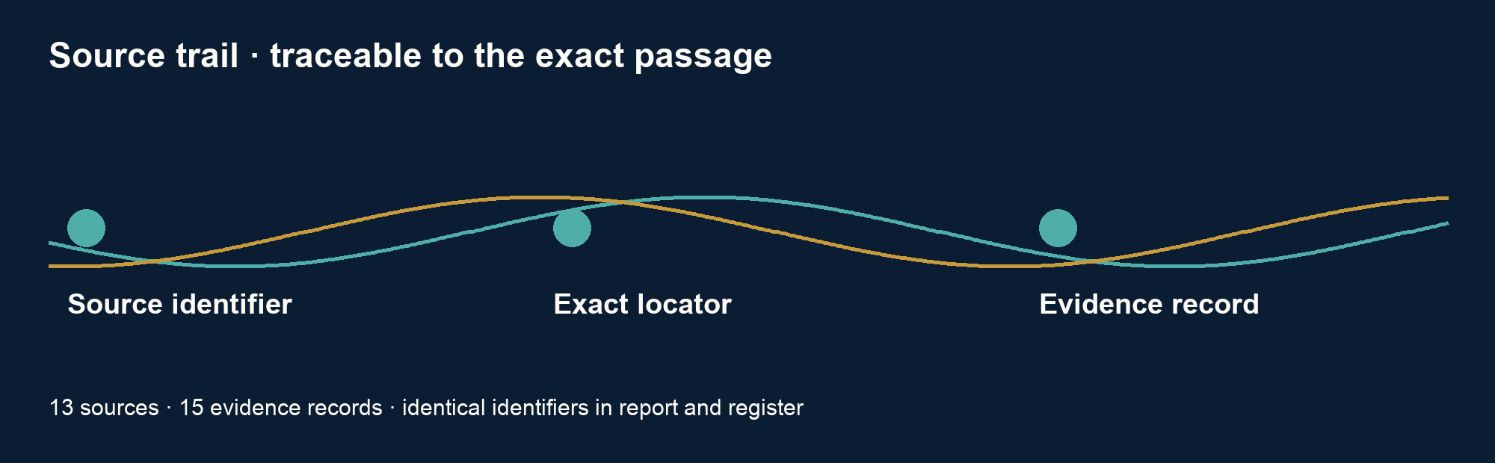

Limitations and documentation

Negative findings and source quality
For false friend, the unusual historical translation examined here provides no positive evidence. For emergence, Leibniz’s mill argument in §17 does not support the Atlas definition: its conclusion concerns perception in a simple substance, not a system property arising from components and interactions [N09; N-S03]. These null findings concern the tested applications, not ILIESI as a whole.
A local inconsistency concerns Cureau: the editorial introduction associates Constance with expansion and Consternation with contraction, while the primary text in Article V assigns them the other way round. Both HTML texts were cross-checked [N-S01-N-S02; Q-CUREAU-01]. This requires checking the relevant summary against the text; it does not justify a general verdict on the portal.
The selection concerns European philosophical texts and is purposive rather than representative. It establishes neither an Atlas-wide yield rate nor broader worldwide language representation. The exact print year and underlying edition of the Latin Descartes version remain unresolved; ILIESI names Henri Desmarets as translator and notes the absence of final checking by Descartes [S05].

Research status and transparency
Research, analysis and report preparation were carried out with AI assistance by Codex at Michael Reich’s request. Technical checks and visual inspection belong to the same workflow. No independent human scholarly review was performed. The English version conveys the same report content and is not an additional review.
The expanded pilot and its documentation are complete. Canonical integration, publication and deeper research have not been carried out. The recommendation is to retain ILIESI at medium priority for a later narrow strand on historical forms of reasoning: perspective first, then analogy/metaphor, followed by affect if needed.

Recommended citation for this report
Reich, Michael (ed.). 2026. ILIESI for Atlas der Sprache. Evaluation report on the expanded research pilot. Version 1.1, 13 September 2026. Atlas der Sprache / Atelier der Resonanzen. ILIESI-REPORT-1.1. AI-assisted preparation by Codex.
The documentation package contains the unchanged original reports and registers, a bilingual evidence and decision register, source metadata, CITATION.cff, BibTeX, a research chronology and checksums. It contains no complete ILIESI source texts. No DOI has been assigned, and no new reuse licence is asserted for the report or package.
