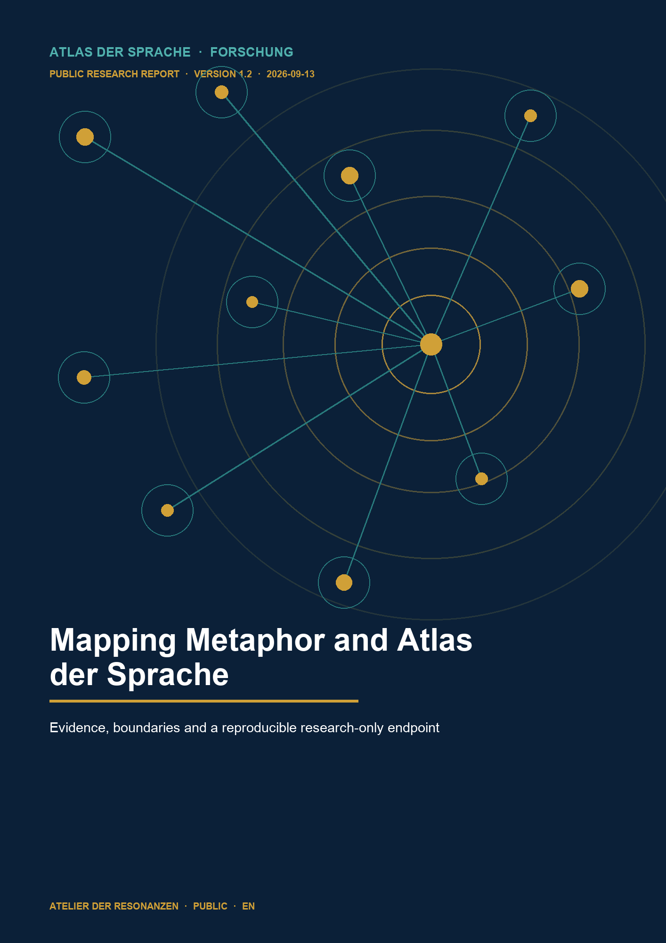

PUBLIC RESEARCH EDITION · VERSION 1.2

Mapping Metaphor and Atlas der Sprache
Evidence, boundaries and a reproducible research-only endpoint
Michael Reich · Atlas der Sprache · 13 September 2026

Abstract
This pilot examined how the Metaphor Map of English can inform existing Atlas der Sprache concepts without identifying categories, word forms, historical senses, theoretical constructs or Atlas identifiers. The initial pilot covered 28 concepts. Michael Reich decided thirteen review cases on 12 September 2026. Ten cases entered three research packages. Eight are supported with explicit scope boundaries and two are partly supported. The thirty AI-internal passages assess consistency and falsifiability rather than human reliability.
The first closure attempt failed because completion still depended on unavailable human coders, raters and audio or video files. Version 1.2 instead completes the source analysis, counterevidence, scope rules, materials development and resonance design that were actually carried out. Human or media validation would constitute a new study.
28 | 13 | 10 | 30
Initial pilot cases | Review decisions | Final cases | AI internal checks

REPORT PROFILE Public research-only evidence edition. It documents sources, decisions, counterevidence and materials without changing Inbox or Atlas data.

Citation and dataset package
Report Reich, Michael. 2026. Mapping Metaphor and Atlas der Sprache. English Research Report. Version 1.2. Public research-only edition. 13 September 2026.
Dataset Reich, Michael. 2026. Mapping Metaphor and Atlas der Sprache Research Only Evidence and Methods Dataset. Version 1.2. Zenodo. https://doi.org/10.5281/zenodo.22735837
External resource Mapping Metaphor with the Historical Thesaurus. 2015. Metaphor Map of English. Glasgow: University of Glasgow. http://mappingmetaphor.arts.gla.ac.uk
The report has no separate DOI. Dataset V1.2 is published on Zenodo with DOI 10.5281/zenodo.22735837. The machine-readable package contains CITATION.cff, CITATION.md, a bilingual README, licence boundaries, checksums and flat CSV tables.

1 Scope and main finding
The project did not derive a new Atlas ontology from the Metaphor Map of English. It tested whether historically directed English category links, direct semantic areas and justified null findings could inform existing Atlas concepts. The central safeguard separates scholarly relevance from identity.
The completed research-only strand has three levels: a 28-case initial pilot, a review matrix with thirteen confirmed decisions and a shortlist of ten evidence cases. Eight cases are supported with scope boundaries. Deictic projection and authority are partly supported.
- The review state remains ten retain-for-review decisions, one defer and two reject decisions.
- Chronotope remains deferred because MME links do not establish its narratological organizing function.
- Only the proposed MME mappings for Deixis and Ideophone were rejected; the Atlas concepts remain intact.
- The reports may be published publicly; Inbox, Atlas and migration status remain unchanged.

2 Data and materials
The primary external source is the Metaphor Map of English, created by Mapping Metaphor with the Historical Thesaurus. The project website describes 415 editorial categories. Shared word forms were identified computationally and then assessed manually for metaphorical transfer. Each direction was checked separately. Strong and weak are editorial evidence classes rather than frequency bands.
The frozen external snapshot covers 32 categories and 96 source files. The local Atlas snapshot contains 1,028 concepts with SHA-256 70aac491852023f13896db7b83c13d3158e31da3a14191b856c992348f83fe24. The connection table records thirteen mapping assertions involving eleven unique external edges. All reverse checks passed.
- Onset dates do not establish continuation or current productivity.
- The project FAQ states that categories do not necessarily correspond exactly to semantic domains.
- The resource does not claim to contain every metaphor in English.
- Historical Thesaurus and Oxford English Dictionary content is referenced through locators; its rights remain separate.

3 Project history
Date | Event | Description | Status
2026-09-11 | Initial pilot | The 28 case pilot was frozen as a research-only dataset. | successful
2026-09-12 | Empirical extension | Blind coding packets norming forms voice QA and video designs were prepared. | preparation only
2026-09-12 | Missing real inputs | No completed human returns or produced media existed. No values were fabricated. | no empirical finding
2026-09-13 | First failed closure attempt | The strand was labelled waiting or paused until real files became available. This was administratively accurate but not a viable project closure because completion depended on unavailable resources. | failed
2026-09-13 | Methodological correction | Human and media validation were removed from the V1 claim. Source work counterevidence scope limits and AI internal consistency checks became the completable V1 core. | corrected
2026-09-13 | Closure V1.2 | The bilingual report citable dataset and resonance design document the full trajectory including the failed attempt. | complete
The sequence explains the unusual project length. After the initial pilot, the work expanded into human coding, sentence norming, voice QA and video production. These extensions were methodologically useful, but they shifted the completion criterion to external participants and real media.

4 The first failed closure attempt
The first failed attempt did not fabricate a dataset or produce a false scientific result. The failure concerned closure logic. On 13 September 2026 the strand was initially described as complete or resting while body videos, norming returns, Chronotope double coding and voice QA were still waiting for real files. The description was administratively honest but left the scientific core open.
Materials and analysis rules existed; empirical inputs did not. Completion nevertheless remained conditional on those missing inputs. A resource constraint became an unlimited project horizon.
What failed Repeated checks of empty return locations could not create evidence. Prepared blind packets and rater workbooks did not constitute a completed study.
What remained valid Packets, identifiers, randomizations, exclusion codes, gates and checksums remained useful methods material. No human judgement, norm value, audio property or perception measure was simulated.
Lesson Closure must refer to work that has actually been completed. A possible empirical follow-up requires a new commission and real inputs.

5 Corrected research design
Version 1.2 separates the research-only core from a possible empirical follow-up. A case is complete when it has a research question, at least two distinguishable source or corpus findings, null or counterevidence, a concrete scope boundary and a source-based judgement. Two prompt-separated AI passages and one adversarial passage test internal stability only.
- Source findings support the specialist judgement.
- Counterevidence limits the claim and prevents overbroad conclusions.
- AI checks may reveal contradictions but do not count as independent raters.
- Human and media studies require real inputs, a new protocol and separate authorization.
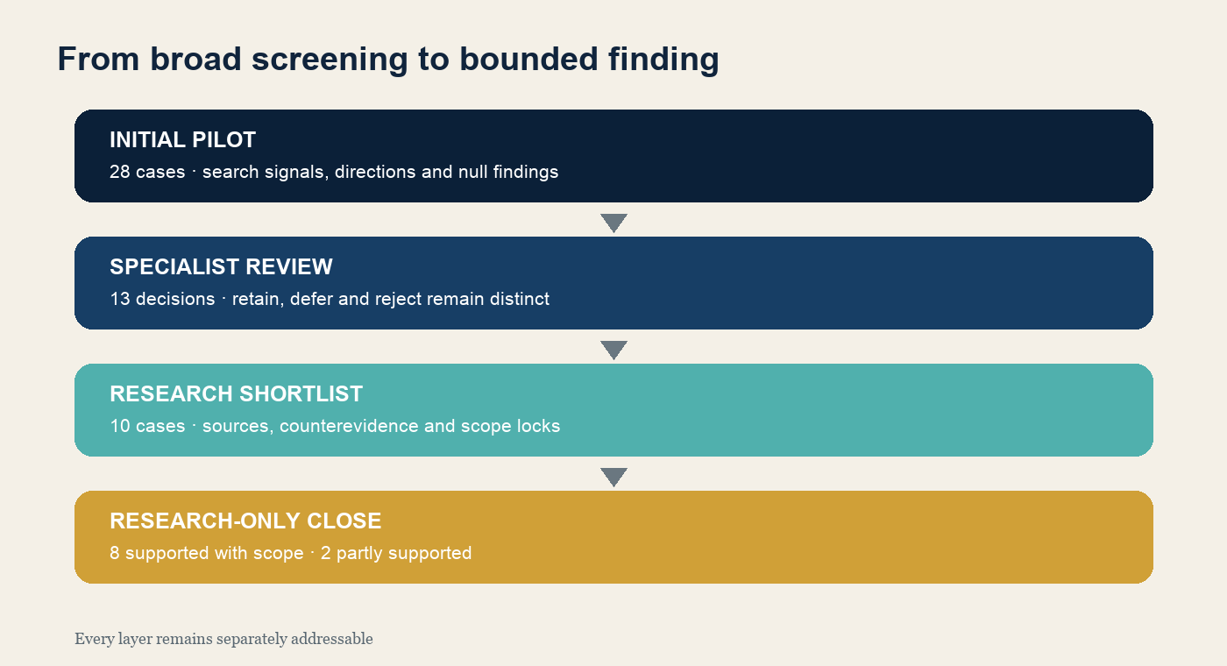
Fig. 1 Four separately addressable levels lead from broad screening to a bounded research finding.

6 Resonance design
In this research edition, resonance design first denotes the visual perspective on knowledge: dark-blue resonance fields, teal connections, gold evidence points, the resonance stream, and dedicated finding and status panels make relations and limits visible. This editorial visual language is separate from the dataset and must not be read as an external research finding.
At the analytical level, the local resonance model records how an external resource bears on an Atlas concept without identifying the two objects. Resonance means a documented and bounded scholarly relation. It is neither an official MME class nor an automatically created Atlas relation.
External resource | Evidence unit | Resonance relation | Scope lock | Research finding
MME category and edge | identifier direction time locator | one of five local types | counterevidence and no identity | research-only status

Grade | Relation | Positive rule | Boundary
R1 | Direct conceptual correspondence | Definition and scope align closely | No category or identifier identity
R2 | Documented directed source target transfer | Source target direction strength and onset are evidenced | No evidence of present productivity or universality
R3 | Language or construction specific realization | Finding is tied to a language sense or construction | No cross-linguistic generalization
R4 | Thematic or network proximity | Proximity guides further research | No identity and no direct transfer evidence
R5 | Negative or null finding | No suitable anchor or the mechanism differs | The null finding remains in the dataset
R1 Direct conceptual correspondence. Definition and scope align closely without implying category or identifier identity.
R2 Documented directed transfer. A supported source-to-target direction informs the Atlas concept; it must not be reversed or generalized.
R3 Language- or construction-specific realization. The finding applies only to the documented language, construction or text type.
R4 Thematic or network proximity. The resource supplies context or a search space but does not establish semantic identity or directed transfer.
R5 Negative or null finding. Missing, conflicting or insufficient evidence explicitly limits the mapping and remains a substantive research result.
Each relation remains tied to its evidence unit. A category code, shared word or visual proximity is insufficient. Direction, strength, onset, sense locators, language scope and counterevidence remain separate. Identity is false in all 28 initial records.

7 Results of the initial pilot
Type | Interpretation | Count
direct_conceptual_correspondence | Direct conceptual correspondence | 7
documented_metaphorical_source_target | Documented directed transfer | 2
language_or_construction_specific_realization | Language or construction specific realization | 1
thematic_or_network_proximity | Thematic or network proximity | 7
negative_or_null_finding | Negative or null finding | 11
The distribution is not a ranking. Direct correspondences and directed transfers identify useful links. Thematic proximity and null findings prevent false identification. Eleven of the 28 cases are negative or null findings; the pilot was not optimized for a high positive rate.
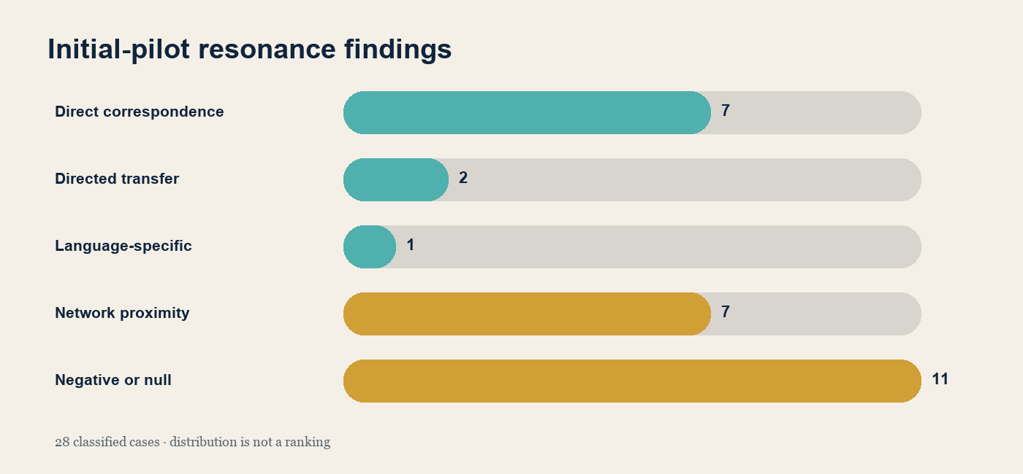
Fig. 2 The resonance classes show scope and limitation; they do not form a ranking.

8 Specialist review and shortlist
Michael Reich reviewed thirteen prioritized cases on 12 September 2026. Ten were retained for further research, Chronotope was deferred, and the proposed MME assignments for Deixis and Ideophone were rejected.
Term | Research finding | Decision | Confidence
Embodiment | documented_metaphorical_source_target | retain-for-review | 0.88
Reason Retain for review. English lexical transfers support a bounded embodiment pattern, not a complete or universal embodiment theory.
Deictic projection | documented_metaphorical_source_target | retain-for-review | 0.90
Reason Retain for review. Spatial-temporal projection is supported, but pragmatic relocation of the deictic centre remains only indirectly covered.
Voice | language_or_construction_specific_realization | retain-for-review | 0.82
Reason Retain for review. MME supports an English lexical link among speech organs and speaking, not the complete Atlas concept of voice.
Body | direct_conceptual_correspondence | retain-for-review | 0.94
Reason Retain for review. Direct body domains are relevant, but relations to gesture, perception and metaphor require separate evidence.
Space | direct_conceptual_correspondence | retain-for-review | 0.93
Reason Retain for review. Several spatial domains correspond directly to part of the Atlas concept without constituting a complete ontology.
Attention | direct_conceptual_correspondence | retain-for-review | 0.96
Reason Retain for review. The core domain is present, but selection and relevance are not fully represented by the MME category.
Affect | direct_conceptual_correspondence | retain-for-review | 0.84
Reason Retain for review. Emotion domains support part of the concept, while bodily and social effects need additional evidence.
Argumentation | direct_conceptual_correspondence | retain-for-review | 0.91
Reason Retain for review. Reason and argument are direct semantic anchors, but structured claim reason relations are not automatically encoded.
Authority | direct_conceptual_correspondence | retain-for-review | 0.90
Reason Retain for review. Legitimacy must remain distinct from power, command, office, expertise and source authority.
Morality | direct_conceptual_correspondence | retain-for-review | 0.95
Reason Retain for review. The morality domain is relevant, but rule systems and action guidance are not automatically established.
Chronotope | thematic_or_network_proximity | defer | 0.78
Reason Defer. Space, time and journey connections do not by themselves establish narrative organization or a Bakhtinian chronotope.
Deixis | negative_or_null_finding | reject | 0.86
Reason Reject the MME mapping only. Spatial and temporal domains do not identify indexical forms or context-dependent deixis.
Ideophone | negative_or_null_finding | reject | 0.91
Reason Reject the MME mapping only. Sensory-speaking proximity does not identify ideophones as a language-specific form class.

9 Final findings for the ten cases

1 Embodiment
Research question Do bodily source domains support a bounded family of transfers without establishing a universal or necessary embodiment thesis?
Positive evidence Historical English mappings and independent Chinese, Korean, German and Indonesian findings support recurring links between body-part or sensation domains and emotion-related meaning.
Null or counterevidence The languages differ in preferred body parts, frequency and conceptual role; amodal and mixed accounts remain viable alternatives.
Scope boundary Supported as a bounded transfer family, not as a universal, necessary or monocausal theory of cognition.
V1 finding supported with scope
Source identifiers EM-S01, EM-S06, EM-S07, EM-S08

2 Deictic projection
Research question Can shifts of the deictic centre be distinguished from ordinary spatial or temporal transfer?
Positive evidence Deixis and viewpoint research describes genuine centre shifts, and an English Persian parallel-corpus study distinguishes genuine from non-genuine perspectival shifts.
Null or counterevidence Spatial-temporal metaphor or a demonstrative change can occur without a shift in origo, speaker viewpoint or character perspective.
Scope boundary The function is supported, but the MME connection is only a search anchor and does not fully represent deictic projection.
V1 finding partly supported
Source identifiers DP-S01, DP-S02, DP-S03

3 Voice
Research question Can bodily sound production, social positioning and perceptible perspective serve as distinct evidence dimensions?
Positive evidence Phonation, socially indexical voice features and perceived affective or social information are supported by separate research traditions.
Null or counterevidence Written voice metaphors and abstract meanings do not support claims about tone, prosody, first-language judgement or concrete speaker perception.
Scope boundary Supported as a three-dimensional test model without inferring social identity or emotion directly from isolated voice features.
V1 finding supported with scope
Source identifiers ST-S02, ST-S04, ST-S05, ST-S06, ST-S08, ST-S09

4 Body
Research question Can body gesture and body perception relations be evidenced case by case without treating the body as one master mechanism?
Positive evidence Gesture research, simulated-action accounts and perception models support specific body gesture and body perception relations.
Null or counterevidence A bodily reference, motion description or idiom is insufficient; critical research permits non-embodied and mixed explanations.
Scope boundary Supported for specified relations, without claiming one bodily origin for all meanings.
V1 finding supported with scope
Source identifiers KO-S02, KO-S03, KO-S04, KO-S05, KO-S06

5 Space
Research question Are spatial reference frames and linguistic spatial relations sufficiently differentiated to form an independent test domain?
Positive evidence Field protocols and cross-linguistic research distinguish relative, intrinsic and absolute frames of reference and separate object from location information.
Null or counterevidence Languages categorize space differently; one prepositional inventory or geometric reading is not a universal spatial ontology.
Scope boundary Supported as a structured and cross-linguistically variable domain, not as a universal one-to-one mapping from form to spatial concept.
V1 finding supported with scope
Source identifiers RA-S01, RA-S02, RA-S03

6 Affect
Research question Can bodily, social and contextual effects of affect be separated well enough to treat affect as a mediating domain?
Positive evidence Affect-infusion and social-emotion research supports effects on judgement, interaction and meaning construction.
Null or counterevidence Emotional expression is context-dependent and not diagnostically unique; similar signals may support different judgements or functions.
Scope boundary Supported as a context-dependent domain of influence without deterministic emotion or meaning readout.
V1 finding supported with scope
Source identifiers AF-S01, AF-S02, AF-S03

7 Attention
Research question Can selection, salience, relevance and omission be operationalized as distinct attentional functions?
Positive evidence Research on orienting, attentional capture, inattentional blindness and relevance supports selection, competing salience and contextual relevance as distinct mechanisms.
Null or counterevidence Salience is not relevance, visibility does not guarantee attention, and omission without a control condition does not prove attentional guidance.
Scope boundary Supported as a multipart test model without equating salience, relevance and conscious perception.
V1 finding supported with scope
Source identifiers AUF-S01, AUF-S02, AUF-S03, AUF-S04

8 Argumentation
Research question Can reason-giving relations, inferential bridges and discursive testing be distinguished from mere assertion or response?
Positive evidence Argumentation theory and annotated corpora operationalize claims, premises or evidence and the relations among them.
Null or counterevidence A statement, answer, disagreement or rhetorical form is not an argument without a reason-giving relation.
Scope boundary Supported as a relational discourse structure; the available MME anchors are indirect and do not constitute a complete argumentation ontology.
V1 finding supported with scope
Source identifiers AR-S01, AR-S02, AR-S03

9 Authority
Research question Can recognized legitimacy be distinguished from coercion, influence, expertise and mere institutional position?
Positive evidence Sociological and organizational research distinguishes legitimate rule or legitimacy from power alone, while information-literacy research differentiates types and contexts of authority.
Null or counterevidence Coercion may be effective without being recognized as legitimate; expertise, office, popularity and source status are not interchangeable.
Scope boundary Partly supported because recognition and legitimacy form a stable core, but distinct carriers and source types must not be collapsed into one uniform concept.
V1 finding partly supported
Source identifiers AT-S01, AT-S02, AT-S03, AT-S04

10 Morality
Research question Are moral values, rules, judgements and action orientation connected while remaining analytically distinct?
Positive evidence Developmental, social-psychological and economic research supports relations among moral judgement, rules, norm focus and behaviour.
Null or counterevidence Conventional rules are not automatically moral, single judgements do not reliably predict conduct, and norms require activation and context.
Scope boundary Supported as a relational family of values, rules, judgements and action guidance, not as a direct or universal judgement action equation.
V1 finding supported with scope
Source identifiers MO-S01, MO-S02, MO-S03, MO-S04, MO-S05

10 AI internal checking
Three checking passages exist for each case. Passage A synthesizes positive evidence, Passage B enforces a narrower scope, and Passage C attacks an overbroad claim. A and B agree on the coarse judgement scale in all ten cases. This is an internal consistency result from the same model system.
- AI outputs are not human judgements or interrater reliability.
- First-language quality, tone, prosody, naturalness and perception remain untested.
- Adversarial passages show only that the scope boundaries make a substantive difference.
- The specialist conclusion rests on sources, counterevidence and defined scope.

11 Materials and empirical boundaries
The materials strand produced 80 body sentences, 40 blinded sentence packets, 48 video design specifications, 30 video rater packets, trilingual voice materials and two Chronotope blind packets. SQA-EN-02 was versioned as R1; BS-043 and BS-044 remained unchanged. These are design and materials outputs.
No completed human packets, produced videos, measured timing markers, audio files, first-language judgements, perception values or human reliability statistics exist. The report therefore makes no claim about population effects, norm values or passed human gates.

12 Dataset and reproducibility
Dataset V1.2 is delivered as an XLSX workbook and a machine-readable package of CSV, JSON, Markdown and CFF files. Every table has a defined observation unit. Initial pilot, review, final cases, AI checks, connections, sources, resonance design and failure history remain separate.
Dataset level | Rows | Function | Boundary
Initial pilot | 28 | Broad MME Atlas screening | Frozen research-only classifications
Specialist review | 13 | Decisions confirmed by Michael Reich | No Atlas integration
Final evidence cases | 10 | Evidence, counterevidence and scope analysis | Eight supported with scope and two partly supported
AI internal checks | 30 | Consistency and falsification prompts | Same model system and no human reliability
Source register | 73 | Citation, provenance, rights and verification | Third-party terms remain separate
- Stable identifiers link cases, sources, reviews and checking passages.
- Checksums establish file identity and provenance rather than human validation.
- CITATION.cff and CITATION.md contain the recommended citation.
- LICENSE_SCOPE.md separates the CC BY 4.0 resource from project annotations and third-party sources.
- Report Version 1.2 is released publicly as a research-only edition. The cited Dataset V1.2 has DOI 10.5281/zenodo.22735837.

13 Limitations and conclusion
The strand shows how MME domains, edges and null findings can inform ten prioritized Atlas concepts. It does not test universality, current productivity, a complete cognitive architecture or empirical effects of the prepared stimuli. The historical English lexicographic basis remains visible.
Within that boundary the project is complete. The failed attempt belongs in the result because it exposed the necessary distinction among prepared materials, real data collection and a defensible scientific endpoint. The corrected version preserves the knowledge gained without replacing absent people or media with claims.

Appendix A Source register
Source identifiers connect this report to Dataset V1.2. The register preserves citation form, verification state or hash, a direct link and the applicable research-only boundary. Source-specific rights remain documented in the dataset.
AF-S01 Forgas, J. P. (1994). The role of emotion in social judgments: An introductory review and an Affect Infusion Model.. DOI 10.1002/ejsp.2420240102 · accessed 2026-09-13 Source. Research-only evidence source; source-specific rights and scope remain recorded in Dataset V1.2; no Atlas identity or publication clearance.
AF-S02 Van Kleef, G. A. & Côté, S. (2022). The Social Effects of Emotions.. DOI 10.1146/annurev-psych-020821-010855 · accessed 2026-09-13 Source. Research-only evidence source; source-specific rights and scope remain recorded in Dataset V1.2; no Atlas identity or publication clearance.
AF-S03 Barrett, L. F. et al. (2019). Emotional Expressions Reconsidered.. DOI 10.1177/1529100619832930 · accessed 2026-09-13 Source. Research-only evidence source; source-specific rights and scope remain recorded in Dataset V1.2; no Atlas identity or publication clearance.
AR-S01 Hitchcock, D. (2005). Good Reasoning on the Toulmin Model.. DOI 10.1007/s10503-005-4422-y · accessed 2026-09-13 Source. Research-only evidence source; source-specific rights and scope remain recorded in Dataset V1.2; no Atlas identity or publication clearance.
AR-S02 Stab, C. & Gurevych, I. (2017). Parsing Argumentation Structures in Persuasive Essays.. DOI 10.1162/COLI_a_00295 · accessed 2026-09-13 Source. Research-only evidence source; source-specific rights and scope remain recorded in Dataset V1.2; no Atlas identity or publication clearance.
AR-S03 Cheng, L. et al. (2022). IAM: A Comprehensive and Large-Scale Dataset for Integrated Argument Mining Tasks.. DOI 10.18653/v1/2022.acl-long.162 · accessed 2026-09-13 Source. Research-only evidence source; source-specific rights and scope remain recorded in Dataset V1.2; no Atlas identity or publication clearance.
AT-S01 Weber, M. (1922/1978). Economy and Society.. accessed 2026-09-13 Source. Research-only evidence source; source-specific rights and scope remain recorded in Dataset V1.2; no Atlas identity or publication clearance.
AT-S02 Suchman, M. C. (1995). Managing Legitimacy: Strategic and Institutional Approaches.. DOI 10.5465/AMR.1995.9508080331 · accessed 2026-09-13 Source. Research-only evidence source; source-specific rights and scope remain recorded in Dataset V1.2; no Atlas identity or publication clearance.
AT-S03 Tyler, T. R. (2006). Psychological Perspectives on Legitimacy and Legitimation.. DOI 10.1146/annurev.psych.57.102904.190038 · accessed 2026-09-13 Source. Research-only evidence source; source-specific rights and scope remain recorded in Dataset V1.2; no Atlas identity or publication clearance.
AT-S04 Association of College and Research Libraries (2015). Framework for Information Literacy for Higher Education.. accessed 2026-09-13 Source. Research-only evidence source; source-specific rights and scope remain recorded in Dataset V1.2; no Atlas identity or publication clearance.
Atlas-Snapshot . 70aac491852023f13896db7b83c13d3158e31da3a14191b856c992348f83fe24 Source. Read-only; no Inbox, migration or publication step.
AUF-S01 Posner, M. I., Snyder, C. R. R. & Davidson, B. J. (1980). Attention and the detection of signals.. accessed 2026-09-13 Source. Research-only evidence source; source-specific rights and scope remain recorded in Dataset V1.2; no Atlas identity or publication clearance.
AUF-S02 Theeuwes, J. (2025). Attentional Capture and Control.. DOI 10.1146/annurev-psych-011624-025340 · accessed 2026-09-13 Source. Research-only evidence source; source-specific rights and scope remain recorded in Dataset V1.2; no Atlas identity or publication clearance.
AUF-S03 Simons, D. J. & Chabris, C. F. (1999). Gorillas in our midst.. DOI 10.1068/p281059 · accessed 2026-09-13 Source. Research-only evidence source; source-specific rights and scope remain recorded in Dataset V1.2; no Atlas identity or publication clearance.
AUF-S04 Wilson, D. & Sperber, D. (2006). Relevance Theory.. DOI 10.1002/9780470756959.ch27 · accessed 2026-09-13 Source. Research-only evidence source; source-specific rights and scope remain recorded in Dataset V1.2; no Atlas identity or publication clearance.
CH-C01 DTA. accessed 2026-09-12 Source. Research-only evidence source; source-specific rights and scope remain recorded in Dataset V1.2; no Atlas identity or publication clearance.
CH-C02 ELTeC. Version and subcorpus fixed before the pilot Source. Research-only evidence source; source-specific rights and scope remain recorded in Dataset V1.2; no Atlas identity or publication clearance.
CH-C03 DraCor. Corpus commit fixed before selection Source. Research-only evidence source; source-specific rights and scope remain recorded in Dataset V1.2; no Atlas identity or publication clearance.
CH-S01 Bakhtin. 1982 edition; essay originally written 1937–1938 Source. Research-only evidence source; source-specific rights and scope remain recorded in Dataset V1.2; no Atlas identity or publication clearance.
CH-S02 De Fina. 2022 Source. Research-only evidence source; source-specific rights and scope remain recorded in Dataset V1.2; no Atlas identity or publication clearance.
CH-S03 Bushell et al.. 2021 Source. Research-only evidence source; source-specific rights and scope remain recorded in Dataset V1.2; no Atlas identity or publication clearance.
DP-S01 Levinson, S. C. (1999). Deixis and Demonstratives.. DOI 10.17617/2.2573810 · accessed 2026-09-13 Source. Research-only evidence source; source-specific rights and scope remain recorded in Dataset V1.2; no Atlas identity or publication clearance.
DP-S02 Chilton, P. (2005). Vectors, viewpoint and viewpoint shift.. DOI 10.1075/arcl.3.06chi · accessed 2026-09-13 Source. Research-only evidence source; source-specific rights and scope remain recorded in Dataset V1.2; no Atlas identity or publication clearance.
DP-S03 Diyanati, M. & Amouzadeh, M. (2025). Deictic projection from English to Persian.. DOI 10.1075/ps.23090.diy · accessed 2026-09-13 Source. Research-only evidence source; source-specific rights and scope remain recorded in Dataset V1.2; no Atlas identity or publication clearance.
EL-S01 ELTeC-deu. v1.0.0 · 08977acb04a401f28484a32784c259b1d4efcf3a Source. CC BY 4.0 where stated in the source record; exact scope remains source-specific.
EL-S02 ELTeC-eng. v1.0.1 · da9908779a0523b8716f4d110b33ba5423a49634 Source. CC BY 4.0 where stated in the source record; exact scope remains source-specific.
EM-S01 MME Body parts. CSV SHA-256 62219bae891dd19c78734c77aaabc8387f41fdb5b8fa1e20ac939ccda30aa176 Source. Research-only evidence source; source-specific rights and scope remain recorded in Dataset V1.2; no Atlas identity or publication clearance.
EM-S02 MME Physical sensation. CSV SHA-256 cbecc2fdc700305e7afc3c0d5652aca5453f2de2a97ce5aaacc21258af78aa1e Source. Research-only evidence source; source-specific rights and scope remain recorded in Dataset V1.2; no Atlas identity or publication clearance.
EM-S03 Maalej & Yu. 2011 · DOI 10.1075/hcp.31 Source. Research-only evidence source; source-specific rights and scope remain recorded in Dataset V1.2; no Atlas identity or publication clearance.
EM-S04 Kövecses. online chapter 2012 · DOI 10.1017/CBO9780511614408.004 Source. Research-only evidence source; source-specific rights and scope remain recorded in Dataset V1.2; no Atlas identity or publication clearance.
EM-S05 Mahon & Caramazza. 2008 · DOI 10.1016/j.jphysparis.2008.03.004 Source. Research-only evidence source; source-specific rights and scope remain recorded in Dataset V1.2; no Atlas identity or publication clearance.
EM-S06 Yu. 2002 · DOI 10.1075/pc.10.1-2.14yu Source. Research-only evidence source; source-specific rights and scope remain recorded in Dataset V1.2; no Atlas identity or publication clearance.
EM-S07 Kim. 2018 · DOI 10.17290/jlsk.2018..82.49 Source. Research-only evidence source; source-specific rights and scope remain recorded in Dataset V1.2; no Atlas identity or publication clearance.
EM-S08 Siahaan. 2011 · DOI 10.1075/hcp.31.08sia Source. Research-only evidence source; source-specific rights and scope remain recorded in Dataset V1.2; no Atlas identity or publication clearance.
KO-S01 MME body domains. 1B09 and 1B11; accessed 2026-09-11 Source. Research-only evidence source; source-specific rights and scope remain recorded in Dataset V1.2; no Atlas identity or publication clearance.
KO-S02 Goldin-Meadow. 1999 · DOI 10.1016/S1364-6613(99)01397-2 Source. Research-only evidence source; source-specific rights and scope remain recorded in Dataset V1.2; no Atlas identity or publication clearance.
KO-S03 Hostetter & Alibali. 2008 · DOI 10.3758/PBR.15.3.495 Source. Research-only evidence source; source-specific rights and scope remain recorded in Dataset V1.2; no Atlas identity or publication clearance.
KO-S04 Barsalou. 2008 · DOI 10.1146/annurev.psych.59.103006.093639 Source. Research-only evidence source; source-specific rights and scope remain recorded in Dataset V1.2; no Atlas identity or publication clearance.
KO-S05 Kelly et al.. 2010 · DOI 10.1177/0956797609357327 Source. Research-only evidence source; source-specific rights and scope remain recorded in Dataset V1.2; no Atlas identity or publication clearance.
KO-S06 Morey et al.. 2022 · DOI 10.3758/s13423-021-01927-8 Source. Research-only evidence source; source-specific rights and scope remain recorded in Dataset V1.2; no Atlas identity or publication clearance.
MM-S01 Mapping Metaphor home. public web access Source. CC BY 4.0 where stated in the source record; exact scope remains source-specific.
MM-S02 About the project. public web access Source. Research-only evidence source; source-specific rights and scope remain recorded in Dataset V1.2; no Atlas identity or publication clearance.
MM-S03 Method. public web access Source. Research-only evidence source; source-specific rights and scope remain recorded in Dataset V1.2; no Atlas identity or publication clearance.
MM-S04 FAQ. public web access Source. Research-only evidence source; source-specific rights and scope remain recorded in Dataset V1.2; no Atlas identity or publication clearance.
MM-S05 User guide. public web access; interactive data may require browser/AJAX Source. Research-only evidence source; source-specific rights and scope remain recorded in Dataset V1.2; no Atlas identity or publication clearance.
MM-S06 How to cite. public web access Source. Research-only evidence source; source-specific rights and scope remain recorded in Dataset V1.2; no Atlas identity or publication clearance.
MM-S07 Copyright notice. public web access Source. CC BY 4.0 where stated in the source record; exact scope remains source-specific.
MM-S08 Stats and figures. public web access Source. Research-only evidence source; source-specific rights and scope remain recorded in Dataset V1.2; no Atlas identity or publication clearance.
MM-S09 Metaphor Map of English browse. public interactive web access; table CSVs are downloadable Source. CC BY 4.0 where stated in the source record; exact scope remains source-specific.
MM-S10 Metaphor Map of Old English. public interactive web access Source. CC BY 4.0 where stated in the source record; exact scope remains source-specific.
MM-S11 Mapping English Metaphor Through Time. publisher access conditions Source. Research-only evidence source; source-specific rights and scope remain recorded in Dataset V1.2; no Atlas identity or publication clearance.
MM-S12 University of Glasgow project-publication record. public web access Source. Research-only evidence source; source-specific rights and scope remain recorded in Dataset V1.2; no Atlas identity or publication clearance.
MME-Kantenliste . 44afd7385afaf5f289ddf7bf26a7801fd00f34ec9efa7a08bef6f58dcbae8b81 Source. Research-only evidence source; source-specific rights and scope remain recorded in Dataset V1.2; no Atlas identity or publication clearance.
MO-S01 Malle, B. F. (2021). Moral Judgments.. DOI 10.1146/annurev-psych-072220-104358 · accessed 2026-09-13 Source. Research-only evidence source; source-specific rights and scope remain recorded in Dataset V1.2; no Atlas identity or publication clearance.
MO-S02 Weston, D. R. & Turiel, E. (1980). Act-rule relations: Children's concepts of social rules.. DOI 10.1037/0012-1649.16.5.417 · accessed 2026-09-13 Source. Research-only evidence source; source-specific rights and scope remain recorded in Dataset V1.2; no Atlas identity or publication clearance.
MO-S03 Turiel, E. (2008). Thought about actions in social domains.. DOI 10.1016/j.cogdev.2007.04.001 · accessed 2026-09-13 Source. Research-only evidence source; source-specific rights and scope remain recorded in Dataset V1.2; no Atlas identity or publication clearance.
MO-S04 Kallgren, C. A., Reno, R. R. & Cialdini, R. B. (2000). A Focus Theory of Normative Conduct.. DOI 10.1177/01461672002610009 · accessed 2026-09-13 Source. Research-only evidence source; source-specific rights and scope remain recorded in Dataset V1.2; no Atlas identity or publication clearance.
MO-S05 Lane, T. et al. (2023). Law and Norms: Empirical Evidence.. DOI 10.1257/aer.20210970 · accessed 2026-09-13 Source. Research-only evidence source; source-specific rights and scope remain recorded in Dataset V1.2; no Atlas identity or publication clearance.
Pilot-Ledger . 0f45681543b21fad0f8da26f475f96a2e7a7024c31ee8e2eae03688cb338cad9 Source. Research-only evidence source; source-specific rights and scope remain recorded in Dataset V1.2; no Atlas identity or publication clearance.
PR-S01 OSF Registrations. accessed 2026-09-12 Source. Research-only evidence source; source-specific rights and scope remain recorded in Dataset V1.2; no Atlas identity or publication clearance.
RA-S01 Levinson, S. C. (1992). A primer for the field investigation of spatial description and conception.. DOI 10.1075/prag.2.1.02lev · accessed 2026-09-13 Source. Research-only evidence source; source-specific rights and scope remain recorded in Dataset V1.2; no Atlas identity or publication clearance.
RA-S02 Levinson, S. C. (1996). Language and Space.. DOI 10.1146/annurev.anthro.25.1.353 · accessed 2026-09-13 Source. Research-only evidence source; source-specific rights and scope remain recorded in Dataset V1.2; no Atlas identity or publication clearance.
RA-S03 Landau, B. (2017). Update on "What" and "Where" in Spatial Language.. DOI 10.1111/cogs.12410 · accessed 2026-09-13 Source. Research-only evidence source; source-specific rights and scope remain recorded in Dataset V1.2; no Atlas identity or publication clearance.
ST-S01 MME speech organs. accessed 2026-09-11 Source. Research-only evidence source; source-specific rights and scope remain recorded in Dataset V1.2; no Atlas identity or publication clearance.
ST-S02 NIDCD. updated 2023-03-13; accessed 2026-09-12 Source. Research-only evidence source; source-specific rights and scope remain recorded in Dataset V1.2; no Atlas identity or publication clearance.
ST-S03 Zhang. 2016 · DOI 10.1121/1.4964509 Source. Research-only evidence source; source-specific rights and scope remain recorded in Dataset V1.2; no Atlas identity or publication clearance.
ST-S04 Podesva. 2007 · DOI 10.1111/j.1467-9841.2007.00334.x Source. Research-only evidence source; source-specific rights and scope remain recorded in Dataset V1.2; no Atlas identity or publication clearance.
ST-S05 Purnell et al.. 1999 · DOI 10.1177/0261927X99018001002 Source. Research-only evidence source; source-specific rights and scope remain recorded in Dataset V1.2; no Atlas identity or publication clearance.
ST-S06 Eckert. 2008 · DOI 10.1111/j.1467-9841.2008.00374.x Source. Research-only evidence source; source-specific rights and scope remain recorded in Dataset V1.2; no Atlas identity or publication clearance.
ST-S07 Scherer. 2003 · DOI 10.1016/S0167-6393(02)00084-5 Source. Research-only evidence source; source-specific rights and scope remain recorded in Dataset V1.2; no Atlas identity or publication clearance.
ST-S08 Kraus et al.. 2019 · DOI 10.1073/pnas.1900500116 Source. Research-only evidence source; source-specific rights and scope remain recorded in Dataset V1.2; no Atlas identity or publication clearance.
ST-S09 Yao et al.. 2026 · DOI 10.1057/s41599-026-07108-z Source. Research-only evidence source; source-specific rights and scope remain recorded in Dataset V1.2; no Atlas identity or publication clearance.
ST-S10 Erickson et al.. 2020 · DOI 10.21437/SpeechProsody.2020-147 Source. Research-only evidence source; source-specific rights and scope remain recorded in Dataset V1.2; no Atlas identity or publication clearance.

Appendix B Data structure and artefacts
Dataset level | Rows | Function | Boundary
Initial pilot | 28 | Broad MME Atlas screening | Frozen research-only classifications
Specialist review | 13 | Decisions confirmed by Michael Reich | No Atlas integration
Final evidence cases | 10 | Evidence, counterevidence and scope analysis | Eight supported with scope and two partly supported
AI internal checks | 30 | Consistency and falsification prompts | Same model system and no human reliability
Source register | 73 | Citation, provenance, rights and verification | Third-party terms remain separate

Recommended citation
Report Reich, Michael. 2026. Mapping Metaphor and Atlas der Sprache. English Research Report. Version 1.2. Public research-only edition. 13 September 2026.
Dataset Reich, Michael. 2026. Mapping Metaphor and Atlas der Sprache Research Only Evidence and Methods Dataset. Version 1.2. Zenodo. https://doi.org/10.5281/zenodo.22735837
Mapping Metaphor Mapping Metaphor with the Historical Thesaurus. 2015. Metaphor Map of English. Glasgow: University of Glasgow. http://mappingmetaphor.arts.gla.ac.uk

Artifact inventory
The listed files constitute the citable research product. Prepared rater packets remain methods material and do not count as empirical returns.
Artifact | Function | Status
Research dataset XLSX | Browsable workbook with linked evidence levels | Version 1.2 · DOI 10.5281/zenodo.22735837
Machine-readable dataset ZIP | CSV JSON Markdown and CFF package | Version 1.2 · DOI 10.5281/zenodo.22735837
CITATION.cff | Software-readable citation metadata | DOI 10.5281/zenodo.22735837
CITATION.md | Human-readable citation guidance | Included
README DE EN | Bilingual structure and use notes | Included
LICENSE_SCOPE.md | Separates project annotations and third-party terms | Included
checksums.sha256 | File identity and provenance | Recomputed for the reports
REPORTS_MANIFEST_v1.2.json | Publication scope and QA record | Updated after rendering

Transparency note
The graphic design belongs to the Atlas perspective on knowledge. Diagrams visualize only the project figures documented in this report; they do not replace external data analysis. Interpretation and metaphor remain visibly editorial and must not be confused with findings of the Metaphor Map of English.
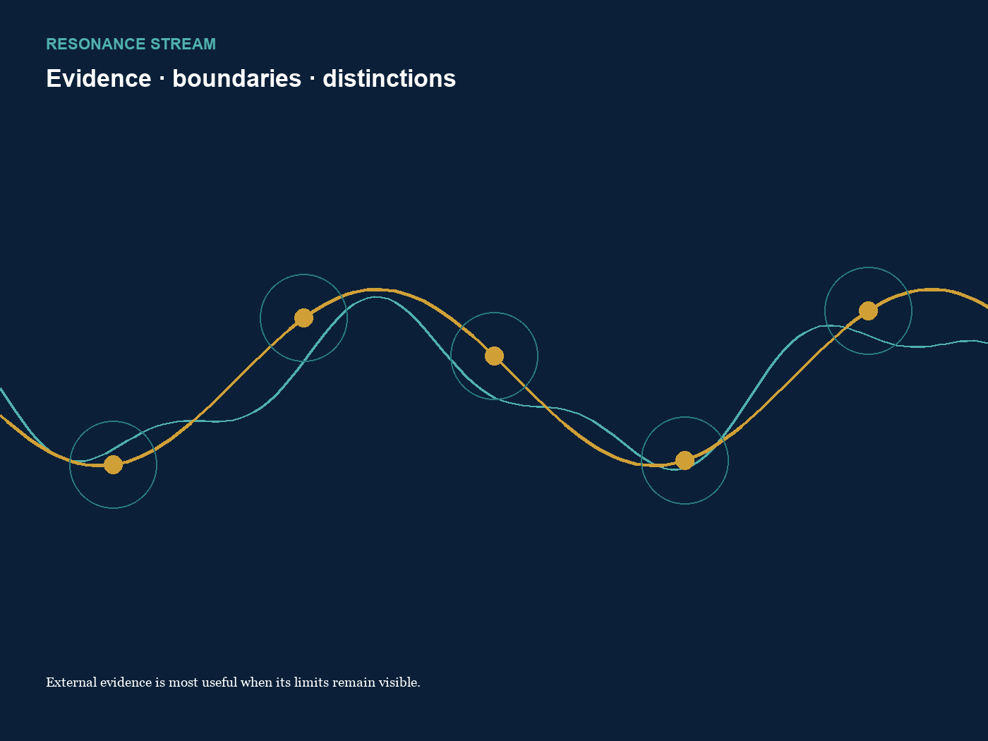
Closing image The resonance design keeps evidence, relation and boundary visible at the same time.
RESEARCH STRAND | EMPIRICAL VALIDATION | ATLAS STATUS
complete within scope | not performed | unchanged

